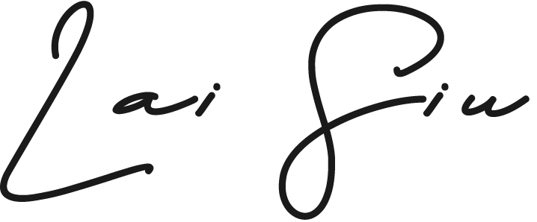
Zack, Siu Kin LAI
 Vancouver, BC
 (778) 875-0062
 zack.laisiu@gmail.com
🌐 www.laisiu.com
Multi-tasking and problem-solving designer with ten years of experience as a Graphic and Marketing Designer. Worked as a senior designer in Fujifilm, and also experienced food and restaurant-related design including Lee Kum Kee. Skilled with Adobe Creative Suite (After Effect, Illustrator, Photoshop), animated digital material, and video promotion. Participated in the whole design process, from understanding needs, brainstorming ideas, and developing visuals to executing designs within tight deadlines.

WORK EXPERIENCE:  Brand Graphic Designer  YIJIA, Canada ⏐ Oct 2023 – Present  - Build and manage creative social media posts and email promotion; create both digital and print marketing materials  - Redesign and upgrade the company’s website from idea to execution in tight budget  Senior Graphic Designer  Fujifilm Business Innovation, Hong Kong ⏐ Nov 2021 - Nov 2022  - Ensured Promotional Campaigns production on time within a tight budget and deadline. Result in rising product attention on social media by 200%  - Estimated project timeline and planning; communicated with suppliers to come up with timeline, budget, special printing requirements  Senior Graphic Designer  Chill Creative Co. Ltd., Hong Kong ⏐ Sep 2014 - Oct 2021  - Produced Soup product Promotional Videos for Lee Kum Kee from storyboard, props prepare, assist shooting, audio recording to video editing; Finally, generated 183,000 views and engaged over 1,000 responses on social media  - Planned and produced the Marketing of Holiday Inn's Restaurant for a whole year from ideas, sketches, layouts, guidelines for photo shooting and photo retouching  - Provide Genki Sushi a Marketing Solution for New Year celebration as a gift to clients  - Create a main visual of Activity by the Wine & Dine Festival from ideas, create marketing material and social media promotion with 3D create tool  - Redesigned a Hotel Website with 3D virtual tour for Holiday Inn Golden Mile HK  - Designed an Informational Animation of a recycling educational park to introduce the process of treatment processes; and manage the production of Cartoon Motion Graphics for the purpose of understanding from children's visitor  - Designed a marketing report and presentation for data analysis  - Led a 3 person team to produce and design marketing projects including print, digital and animation; create various graphic illustration such as posters, packaging, presentation, exhibition and brochures | EDUCATION:  Bachelor of Graphic Design at Coventry University, UK  Jun 2021  Associate's Degree of Visual Communication (Information Design) at HKDI, HK  Jun 2013  SKILLS:  Adobe Suite (After Effects, Illustrator, Photoshop, InDesign and XD)  Infographic  Typography  Exhibition  Design Thinking  Information architecture  Mobile app UI design  Responsive website  User research and analysis  Printing Knowledge  3D Knowledge  HTML & CSS Knowledge  LANGUAGES:  English  Cantonese  Mandarin

