Two Types of Citizenship in America — Most Don’t Know This Exists
- After the Civil War, Congress created a second class of citizenship through the 14th Amendment (1868).
- Before that, Americans were simply state citizens — born into their sovereign state of the Union (like Arkansas or Texas). They were not under federal jurisdiction unless they voluntarily submitted to it.
- The 14th Amendment created a new, corporate-style citizen: “All persons born or naturalized in the United States... are citizens of the United States...”
This was not the original form of citizenship. It was federal, contractual, and administrative.
Congress Used Legal Definitions to Pull a Fast One
In 8 U.S.C. § 1101, Congress redefined key terms:
- § 1101(21) – “The term ‘national’ means a person owing permanent allegiance to a state.” This refers to the original, lawful citizenship — allegiance to your sovereign state (not the federal government).
- § 1101(22) – “National of the United States” means someone who owes allegiance to the United States. This is the federal citizen class — a statutory creation, not a natural political status.
- § 1101(23) – “Naturalization” means the conferring of nationality... by any means whatsoever.
This gives you the power to declare and reclaim your lawful standing outside federal jurisdiction.
Federal Jurisdiction Only Applies to Federal Zones
Congress defines “State” in many statutes (like 8 U.S.C. § 1101(a)(36)) as: “The term ‘State’ includes... the District of Columbia, Puerto Rico, Guam, and the Virgin Islands.”
This has nothing to do with the 50 sovereign states of the Union. Most people assume they’re “from a state,” but in legal language, they’ve been contracted into federal zones.
By Checking a Box, You Claimed to Be a Federal Worker
When you:
- Check “U.S. citizen” on a form
- File a 1040 tax return
- Apply for federal benefits
- Get a Social Security Number
...you unknowingly declare yourself a “citizen of the United States” — a federal person, not a living man or woman of the original Union.
This status places you:
- Under administrative jurisdiction
- Subject to federal income tax
- Liable to federal courts and codes
- With only “civil rights” (revocable), not God-given rights (unalienable)
The Slaughterhouse Cases Prove It All
In the Slaughterhouse Cases (1873), the U.S. Supreme Court confirmed there are two separate citizenships: one of the United States (federal) and one of the State (sovereign).
Most people today only have the federal version — because no one told them otherwise.
The Government Style Manual Even Tells You the Truth
The U.S. Government Publishing Office Style Manual, § 5.23, says:
- “State” (capitalized) = a sovereign political entity (like “State of Arkansas”)
- “state” (lowercase) = general or federal use
So when you see “state” in lowercase in legal codes, it's not referring to your sovereign land — it's referring to federal administrative zones.
Your Remedy — Declaring Your Lawful Status
8 U.S.C. § 1101(23) allows you to declare nationality “by any means whatsoever.” That means you can:
- Write and record an Affidavit of Political Status
- Publish a Declaration of Nationality
- Notify courts and agencies that you are not a 14th Amendment U.S. citizen
- Reassert your standing as a living man or woman of your State — not a federal employee, subject, or fiction
Summary Table — Which One Are You?
If you don’t correct the record, you will always be treated as a federal subject, not a living man or woman of the original Union. You are presumed to be owned, unless you say otherwise.

UCC 1-308, ALL RIGHTS RESERVED, WITHOUT PREJUDICE, UCC 1-304 NOT LEGAL NOR TAX ADVICE
Standing | Jurisdiction | Created By | Rights Type
Freeman of the Union | Your state republic | God / birth | Unalienable
14th Amendment Citizen | Federal government | Congress (1868) | Civil (revocable)
Federal subject/person | D.C. / federal zones | Corporate codes | Administrative
Nothing in this section is intended as legal advice, nor as a statement that civil safety, titling, registration, insurance, or licensing requirements do not apply. Ministers and ministries are encouraged to remain peaceful, transparent, and compliant with applicable public-safety and administrative requirements while conducting ministerial activities.

*When discussing legal terminology (e.g., “driver,” “motor vehicle,” “carrier,” “commercial”), the ministry notes that definitions can vary by context and statute. Where questions arise about the meaning or applicability of statutory terms to a particular activity, consult qualified counsel and rely on primary legal sources.

Ministerial Transportation Classification and Administrative Documentation
In addition to the theological and stewardship principles described above, some ministers and ministry stewards elect to document transportation resources used in ministerial service through available administrative transportation classification systems.
In certain cases, ministers may maintain transportation classifications recognized within federal transportation registration systems as Private Passenger Motor Carrier — Non-Commercial Only (Non-Business) and/or Private Property Motor Carrier — General Freight, when such classifications are assigned through administrative registration processes.
Where applicable, ministers may be issued a United States Department of Transportation (USDOT) identification number for administrative recordkeeping, transportation classification, and regulatory identification purposes.
Transportation resources associated with such classifications may be utilized in support of ministerial responsibilities including pastoral visitation, religious assembly coordination, charitable outreach, ecclesiastical administration, and mission-related activities.
Ministers who maintain such transportation classifications may utilize transportation identification plates or markings displaying assigned USDOT identification numbers or private carrier designations as part of ministerial documentation, stewardship transparency, and transportation identification practices.

Ministerial Transportation Identification Exhibit
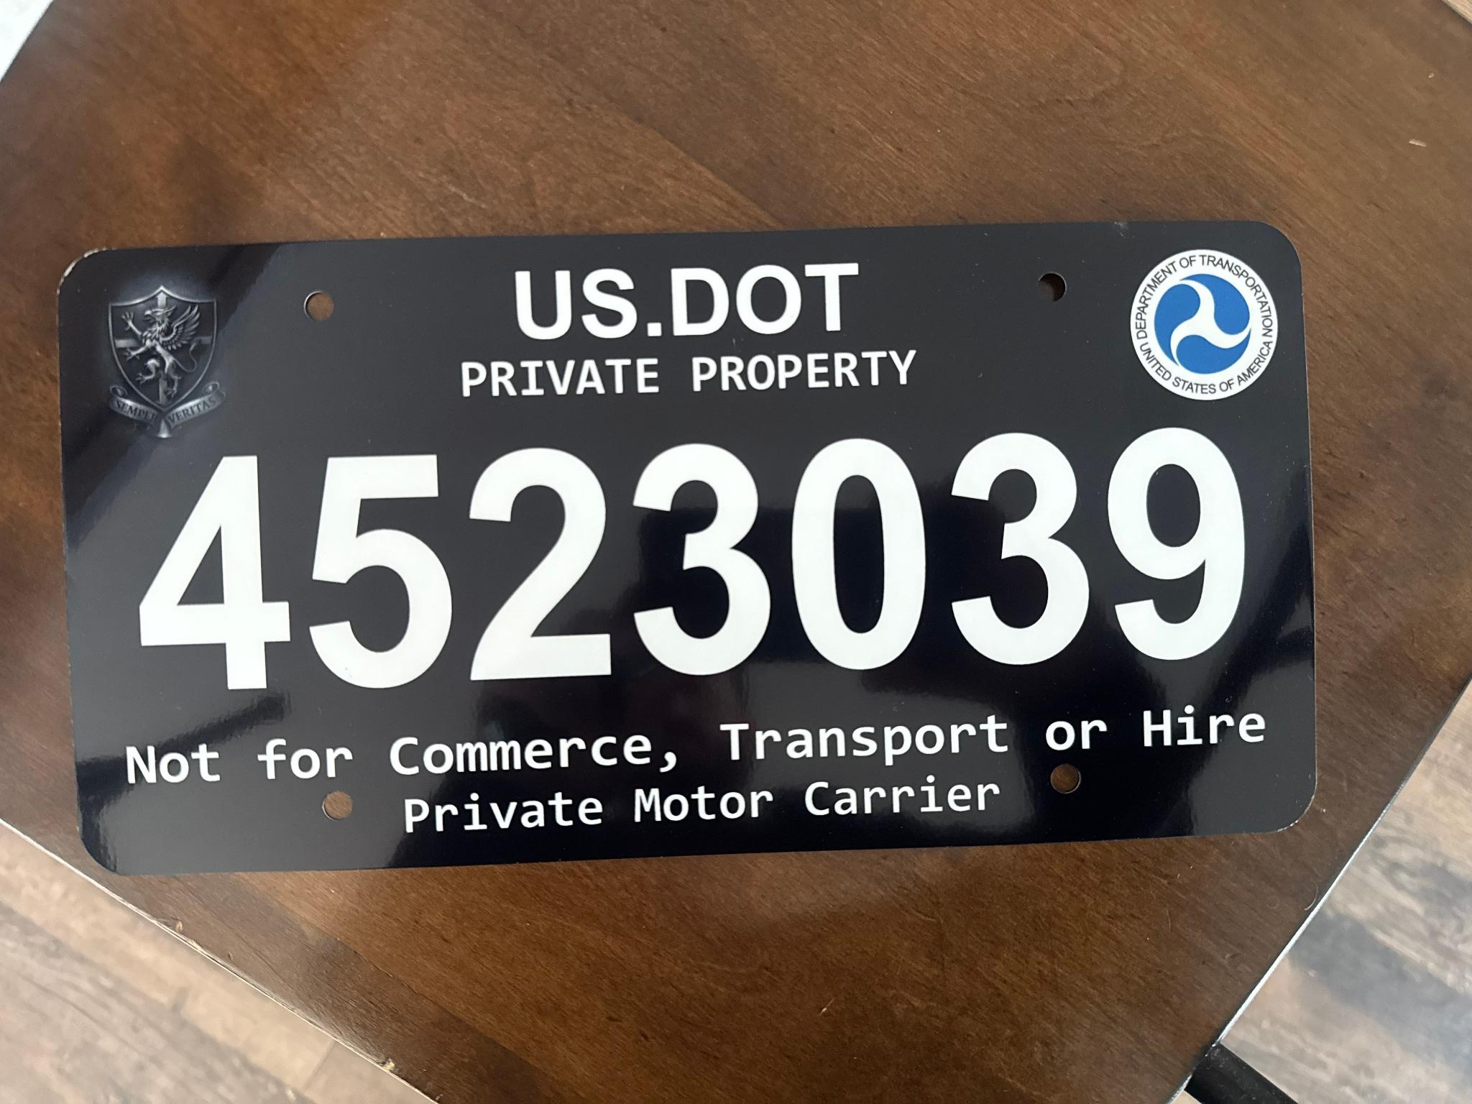

Variability of Statutory Transportation Definitions
It is recognized that statutory definitions of terms such as “motor vehicle,” “carrier,” “driver,” and related transportation classifications vary significantly among individual states and jurisdictions. Many statutory definitions are highly specific, often limited by factors such as vehicle weight, commercial activity, passenger or freight service, interstate operation, or other regulatory thresholds.
Because transportation statutes and administrative codes differ between jurisdictions, legal interpretation and case law addressing transportation classifications may vary widely across states and regulatory venues. Courts and administrative agencies in different jurisdictions have historically addressed transportation classification issues using differing statutory frameworks, fact patterns, and legal arguments.
Accordingly, ministers, stewards, and ministry organizations that study or discuss transportation terminology frequently acknowledge that transportation-related definitions are context-dependent and jurisdiction-specific. Ministers and ministry stewards are encouraged to review primary statutory language, administrative regulations, and relevant case law applicable to the jurisdiction in which transportation activity occurs, and to seek qualified guidance where clarification is necessary.*

