DANCING THROUGH NEVERLAND 2027
SUNDAY 14th March – Cumnor House Sussex

Dear Parents and Students,
We are so excited to announce Nova School of Dance is inviting ALL of its students and families to join us to attend our upcoming Showcase. This event shall contain a dance performance from each class, a chance for our superstars to shine on stage.

The countdown begins - this promises to be the school event of the year and the hard work has already begun!

Please find detailed below our starter information for the event - a full breakdown will be released nearer the time.

- Please note it is extremely important that classes are not missed whilst working on this presentation.
- If you cannot take part in the presentation for any reason, then please notify us straight away. Students will still take part in all classes, but it helps us when spacing routines to know at the start if they cannot take part.

Participation Fee:

The fee to take part in the showcase is detailed below. This fee contributes towards our show admin, dress rehearsal, insurance, the cost of the theatre hire, staff/chaperones and finale t-shirt.

Your show fee of £30.93 must be paid in full by Monday 2nd November and all fees are non-refundable.

General Information:

- All students who wish to be involved shall perform in a one act presentation of various dance genre choreography.
- The more classes your child attends, the more opportunity to perform they shall receive! Furthermore, we’ll be organising some further dances to offer to students as added extras.
- We shall be organising costumes with set hair.
- A general rehearsal and dress rehearsal shall be required for all students in the venue to practise together and recognise the correct performance etiquette.

Box Office:

- Tickets will go on sale on Monday 18th January 2027
- Tickets are priced at £8.00 for adults, £5.00 for Children and can be purchased exclusively online via Stagestubbs, a link shall be sent closer to the time.
- If you encounter any problems when booking tickets, please contact us directly.

Run Through & Dress Rehearsal (Compulsory):

- The Run Through/dress rehearsal is on SUNDAY 14th MARCH, we’ll be staggering our arrival times via age, though roughly pencil in 10.00AM.
- ALL cast MUST attend with full costumes and hair.
- Furthermore, other group rehearsals maybe added closer to the time, to which you shall be contacted.
Costumes:

- Costumes will begin to be handed out during lessons nearer the show.
- Keeping costume costs at an all-time low, (though we'll be sure they'll look fabulous!) we have set a budget of £15.00 per costume.
- Some costumes will be given to your dancer to keep, others shall be hired and will need to be returned in a respectable condition.
- You will be asked to provide your own shoes, tights, leggings, hair accessories etc.

Paying Your Show Fee:
Please click link here > Dancing Through Neverland '27 SHOW FEE
Please visit the following link and complete make your show payment online by 2nd November 2026.
Costumes Fees will be staggered and sorted separately.

Online Permission Form

It is a legal requirement that we have permission for your child to take part, to be filmed/photographed on the day and for these images to be used for any school promotional purposes. Please visit the following link and complete the summer show permission form online by 2nd November 2026.

Please click here to fill out our form > Nova Showcase Consent Form '27
That is all the information available for now, letter number 2 will be sent out nearer the time detailing further information on day.

Happy show term and watch out for details coming soon!

Best wishes,

Miss Natasha
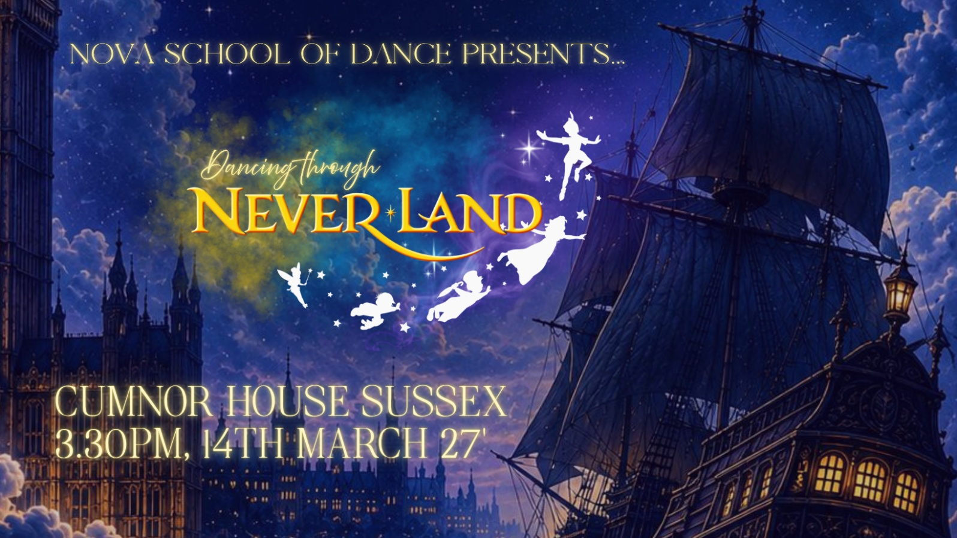
Principal, Nova School of Dance
Miss Jessie & Miss Morgan, Nova Team Teachers

