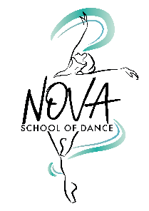
Nova School of Dance Data Protection Policy
Data Collection and Use upon Registration
We collect personal information including names, contact details, dates of birth, and emergency contact information. This data is used solely for legitimate operational purposes, including:
- Communicating about classes, events, and performances
- Providing updates on school news, CPD, and support
- Managing bookings, uniform orders, and invoices
- Sending important notifications or responding to specific requests
- Gathering feedback to improve our services
We will only use your data with your explicit consent and for the purposes outlined above.
Data Storage and Access
- Registration forms are securely stored in locked or password-protected systems.
- Teachers are provided with class registers containing names, dates of birth, and emergency contacts. They are responsible for ensuring this information is kept confidential and secure.
- If your personal information changes, or if you believe any data we hold is inaccurate, please notify us so we can update our records
Sharing of Data
Nova School of Dance does not share your data with third parties except in the following legally permitted and consent-based circumstances:
- Examinations: Student names and dates of birth will be submitted to accredited dance boards (e.g., ISTD) with parental consent.
- Performances: Information such as student names, dates of birth, and addresses may be shared with Surrey/ East Sussex County Council for performance licensing, with parental consent.
- Advertising: Photographs and videos used for promotional purposes will only be published if media consent has been granted via the registration form. Identifying names will not be shared without additional permission.
Data Retention and Destruction
- If a student leaves Nova School of Dance, their registration form will be securely destroyed.
- Bank details, when provided for refunds or transactions, may be retained solely for financial record-keeping.
- With prior consent, Nova may retain class footage or event images for use on our website, social media, and marketing materials. No content will be used without consent.
Your Rights Under GDPR, you have the right to:
- Access your data
- Request correction of inaccurate data
- Request deletion of your data
- Object to processing or request data portability
- Withdraw consent at any time To exercise these rights, please contact the principal at novaschoolofdance@gmail.com.

