|  |
| --- |
| Monroe Fire Protection District |

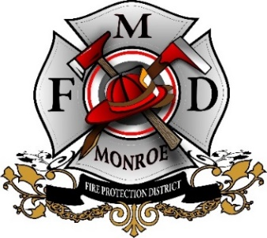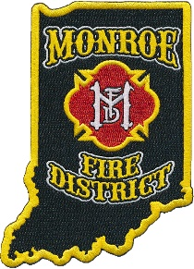

**MFD has partnered with the US Department of Veteran Affairs (VA) and the Substance Abuse and Mental Health Service Administration (SAMHSA) to help with the Governor’s Challenge. The Governor’s Challenge is taking place in all US States and Territories to develop and implement state-wide suicide prevention measures. A goal of the Governor’s challenge is to prevent suicide among service members, veterans, and their family members by developing and implementing a state-wide prevention program.**

**MFD’s partnership is to help our veterans or anyone else in our community connect with mental health agencies like the VA to help get individuals any help they may need, and to provide them with safety measures to help limit the chance of suicide.**

**All seven MFD fire houses, plus the majority of our trucks have supplies that can be handed out to individuals in hopes of limiting their risk to harmful means. In these kits are gun locks, and medicine take back bags.**

**Any individual, not just Veterans, needing these supplies can pick them up at one of our seven fire stations located at:**

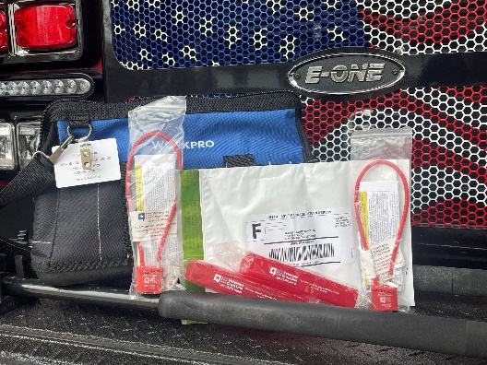

**Station 21 – 9094 S Strain Ridge Rd**

**Station 22 – 3953 S Kennedy Dr**

**Station 23 – 8019 S Rockport Rd**

**Station 24 – 7606 E State Rd 45**

**Station 25 – 5081 N Old State Rd 37**

**Station 29 – 2130 S Kirby Rd**

**Station 39 – 9039 W Hinds Rd**

**For anyone having suicidal thoughts we encourage you to seek help and contact the national suicide prevention help line at 988.**

**More information on the Governor’s Challenge can be found at:** [**https://www.samhsa.gov/smvf-ta-center/mayors-governors-challenges**](https://www.samhsa.gov/smvf-ta-center/mayors-governors-challenges)

[**#veterans**](https://www.facebook.com/hashtag/veterans?__eep__=6&__cft__%5b0%5d=AZV4teX0Xyty0F3V3B7nMWLVlvtCiIvO_3SVU3MoeDSJwqK00zkQUrfvtVIydvCvgLVTos3-tuP2ZnQZNcj2kZPT9WmOgPP7Ac27caP2oNvEfAGKxp_8tqPEEjRbpulASM7kN8hM4nvSv92BUJS6P9RtUAqnPwpEX7mn7i3BhYLNlk1CVQvO1aKM5L9zL64pgOw&__tn__=*NK-R)

****[**#veteranaffairs**](https://www.facebook.com/hashtag/veteranaffairs?__eep__=6&__cft__%5b0%5d=AZV4teX0Xyty0F3V3B7nMWLVlvtCiIvO_3SVU3MoeDSJwqK00zkQUrfvtVIydvCvgLVTos3-tuP2ZnQZNcj2kZPT9WmOgPP7Ac27caP2oNvEfAGKxp_8tqPEEjRbpulASM7kN8hM4nvSv92BUJS6P9RtUAqnPwpEX7mn7i3BhYLNlk1CVQvO1aKM5L9zL64pgOw&__tn__=*NK-R)

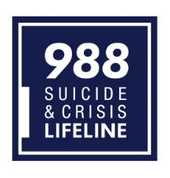[**#SuicideandCrisisLifeline**](https://www.facebook.com/hashtag/suicideandcrisislifeline?__eep__=6&__cft__%5b0%5d=AZV4teX0Xyty0F3V3B7nMWLVlvtCiIvO_3SVU3MoeDSJwqK00zkQUrfvtVIydvCvgLVTos3-tuP2ZnQZNcj2kZPT9WmOgPP7Ac27caP2oNvEfAGKxp_8tqPEEjRbpulASM7kN8hM4nvSv92BUJS6P9RtUAqnPwpEX7mn7i3BhYLNlk1CVQvO1aKM5L9zL64pgOw&__tn__=*NK-R)