|  |
| --- |
| Monroe Fire Protection District |

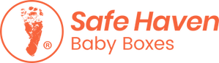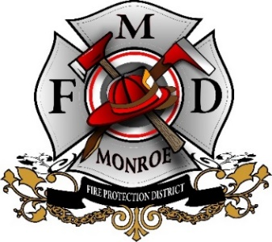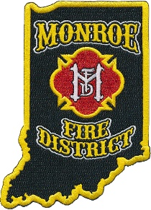

**The Safe Haven Baby Box takes the face-to-face interaction out of the surrender and protects the mother from being seen. The Safe Haven Baby Boxes organization's primary goal is to raise awareness of the Safe Haven Law. Women in crisis can call the national 24-hour hotline and can receive counseling and assistance free of charge. To date, the hotline has received over 9,000 calls from every state in the United States. Safe Haven Baby Boxes has referred over 500 women to crisis pregnancy centers, assisted in 9 adoption referrals, and have had over 140 legal Safe Haven surrenders. Forty-Three babies have been surrendered in our Baby Boxes. Three babies were surrendered directly to firefighters at Safe Haven Baby Box locations.**

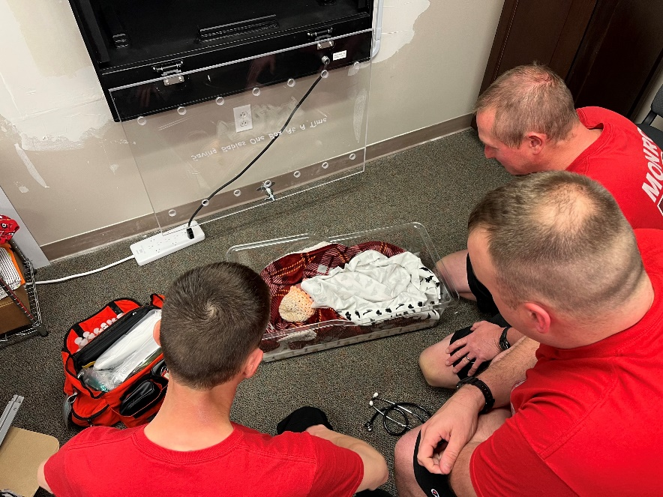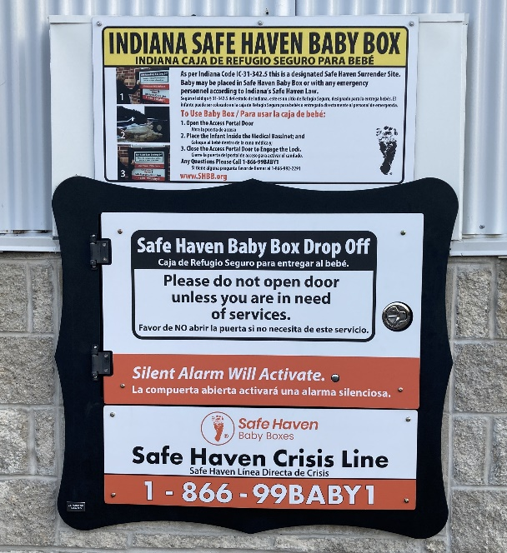**On April 8, 2023 a child was surrendered in the Baby Box located at:**

**Station 25 5081 N Old SR 37**