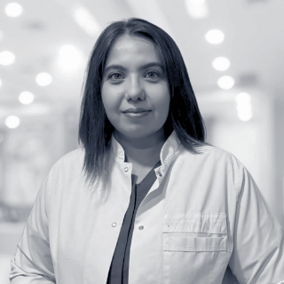

MD Kadriye İpek Uzunoğlu

🏥 Specialty: Aesthetic, Plastic and Reconstructive Surgery

📍 Birthplace / Year: Tokat, Turkey, 1985

🗣 Languages: Turkish | English

## Medical Experience

2025 – Present: MEMORIAL ŞİŞLİ HOSPITAL, Plastic, Reconstructive, and Aesthetic Surgery Specialist  
2024 – 2025: BAYPARK HOSPITAL, Plastic, Reconstructive, and Aesthetic Surgery Specialist / Istanbul  
2024 – 2024: BAĞCILAR TRAINING AND RESEARCH HOSPITAL, Plastic, Reconstructive, and Aesthetic Surgery Specialist  
2021 – 2024: KONYA CITY HOSPITAL, Plastic, Reconstructive, and Aesthetic Surgery Specialist  
2018 – 2021: KONYA TRAINING AND RESEARCH HOSPITAL, Plastic, Reconstructive, and Aesthetic Surgery Specialist  
2017 – 2018: SİVAS NUMUNE HOSPITAL, Plastic, Reconstructive, and Aesthetic Surgery Specialist  
2011 – 2017: SİVAS CUMHURİYET UNIVERSITY FACULTY OF MEDICINE, Plastic, Reconstructive, and Aesthetic Surgery Specialist  
2011 – 2011: REŞADİYE STATE HOSPITAL, Emergency Doctor  
2010 – 2011: TOKAT 112 EMERGENCY SERVICE, Emergency Doctor

## Medical Education

2011 – 2017: SİVAS CUMHURİYET UNIVERSITY FACULTY OF MEDICINE, Plastic, Reconstructive, and Aesthetic Surgery Residency Training / Sivas, Turkey  
2015: UNIVERSITY OF ALABAMA AT BIRMINGHAM, Division of Plastic Surgery, Observer / USA  
2003 – 2010: SAMSUN ONDOKUZ MAYIS UNIVERSITY FACULTY OF MEDICINE / Samsun, Turkey

## Trainings and Courses

Cumhuriyet Univ. Laboratory Animal Use Certification Course  
TPRECD 45th National Congress  
TPRECD 8th Rhinoplasty Course  
TPRECD 1st Facial Aesthetics Course  
TPRECD Winter Symposium 2016  
EPCD 20th National Congress  
RMCD XIX Basic Microsurgery Course  
TPRECD 9th Plastic Surgery School  
EPCD 28th National Congress  
TPRECD XIII Rhinoplasty and VI Facial Aesthetics Course

## Professional Associations

Turkish Medical Association  
Turkish Society of Plastic Reconstructive and Aesthetic Surgery  
Turkish Society of Aesthetic Surgery  
Women Doctors Education Support Foundation