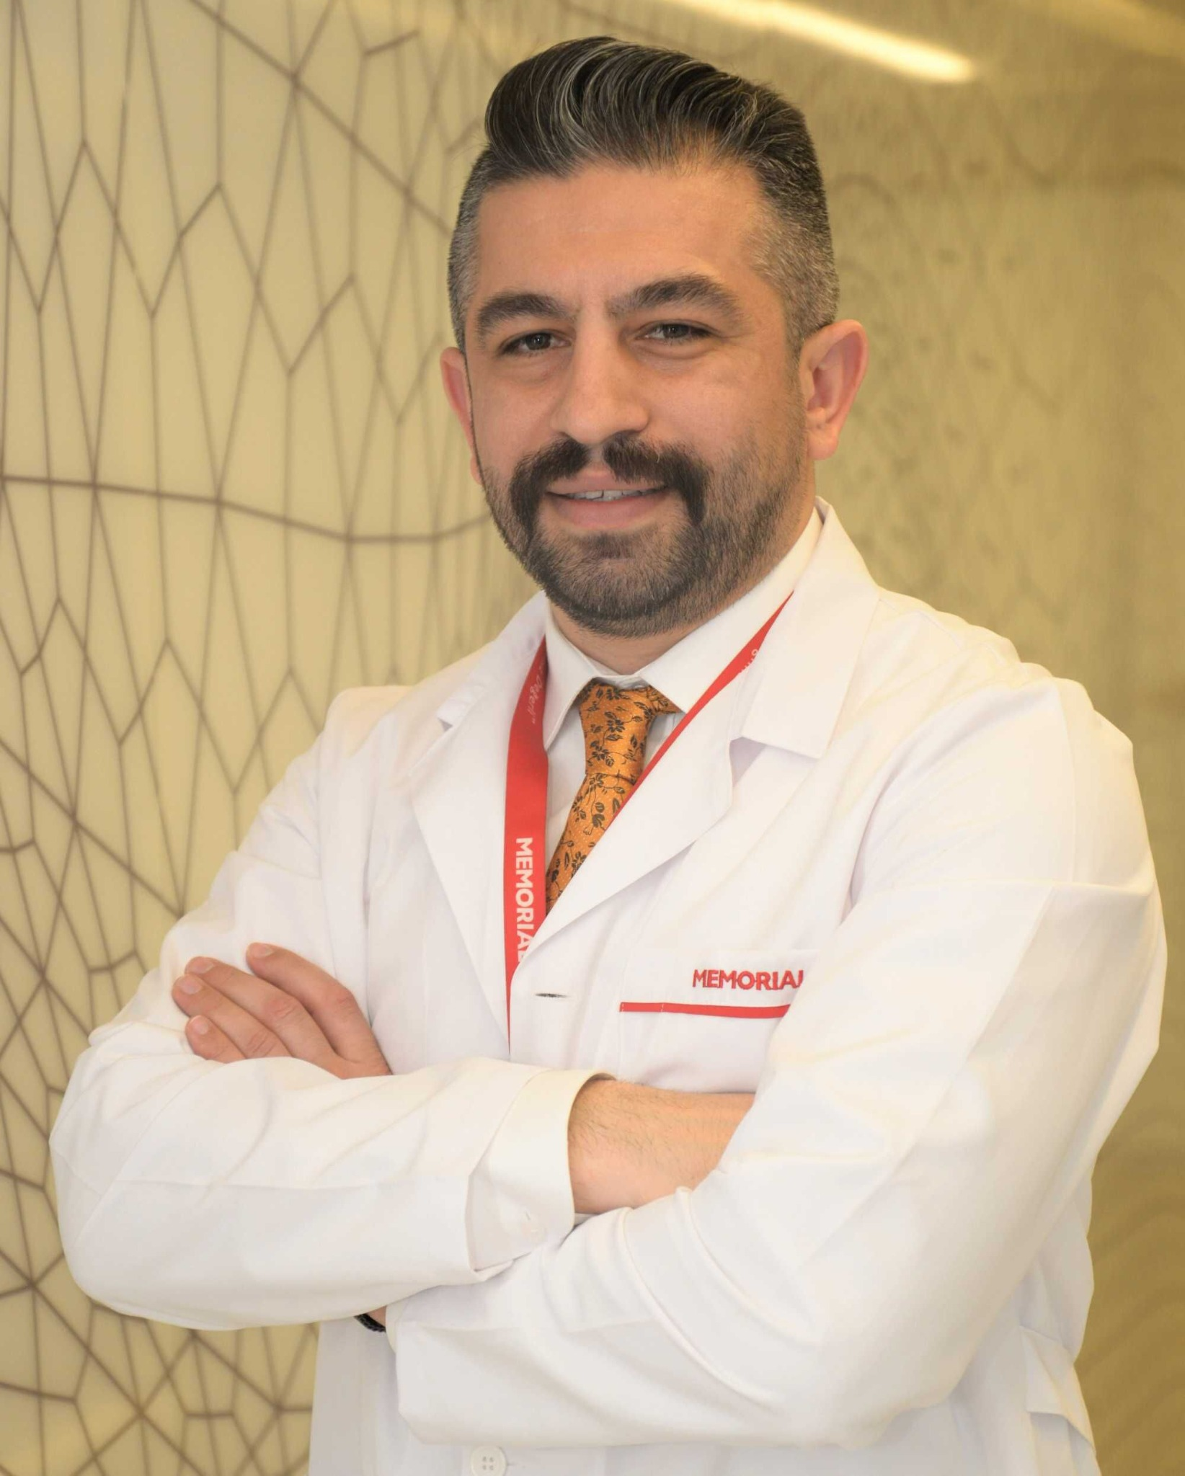

Op. Dr. Vahit MUTLU

General Surgery Specialist

## Professional Experience

2023 - Present: MEMORIAL ATAŞEHİR HOSPITAL, General Surgery Specialist / Istanbul

2021 - 2022: TOKAT STATE HOSPITAL, General Surgery Specialist / Tokat

2015 - 2020: ONDOKUZ MAYIS UNIVERSITY FACULTY OF MEDICINE, Research Assistant - General Surgery Department / Samsun

2013 - 2015: ERZINCAN MENGÜCEK GAZİ TRAINING AND RESEARCH HOSPITAL, General Practitioner / Erzincan

## Medical Education

2015 - 2020: ONDOKUZ MAYIS UNIVERSITY FACULTY OF MEDICINE / Samsun, Turkey

2006 - 2013: ONDOKUZ MAYIS UNIVERSITY / Samsun, Turkey

## Scientific Publications

Multiple articles and presentations published in international and national peer-reviewed journals.

## Professional Trainings, Courses, and Conferences Attended

TKRCD SELIM ANORECTAL DISEASES

CLINICAL IMMERSION LAP VENTRAL AND INGUINAL HERNIA REPAIR

CERTIFICATE FOR THE USE OF LABORATORY ANIMALS

TURKISH ANESTHESIOLOGY AND REANIMATION ASSOCIATION OBESITY AND ANESTHESIA

15th THPB SURGERY CONGRESS (including various courses)

TURKISH COLON AND RECTAL SURGERY CONGRESS

CERTIFICATE OF SURGICAL ENDOSCOPY TRAINING

## Memberships in Professional Associations and Organizations

Turkish Surgical Society

Turkish Hepato-Pancreato-Biliary Surgery Association

Turkish Obesity Surgery Foundation

TOSS (Turkish Obesity Surgery Association)

IFSO (International Federation for the Surgery of Obesity and Metabolic Disorders)

Turkish Liver Research Association

GlobalSurg Collaborative

International Bariatric Club