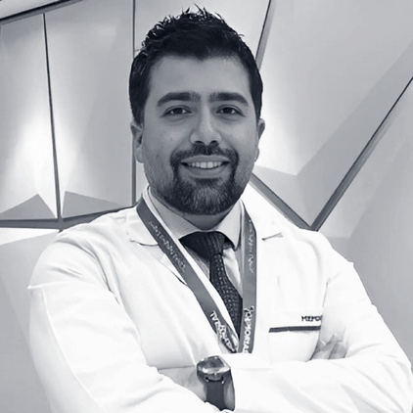

Assoc. Prof. Dr. Mehmet Celal KIZILKAYA

Birthplace / Year: Adıyaman, Turkey, 1984

Languages: Turkish | English

General Surgery Specialist

## Medical Experience

2025 – Present: MEMORIAL BAHÇELİEVLER HOSPITAL, General Surgery Specialist / Istanbul, Turkey  
2023 – 2025: ACIBADEM ATAKENT HOSPITAL, General Surgery Specialist / Istanbul, Turkey  
2021 – 2023: KANUNI SULTAN SULEYMAN TRAINING & RESEARCH HOSPITAL, Chief Assistant - Associate Professor (2023) / Istanbul, Turkey  
2018 – 2021: KANUNI SULTAN SULEYMAN TRAINING & RESEARCH HOSPITAL, General Surgery Specialist / Istanbul, Turkey  
2015 – 2018: S.B.U. SAMSUN TRAINING AND RESEARCH HOSPITAL, General Surgery Specialist / Samsun, Turkey  
2014 – 2015: BULANIK STATE HOSPITAL, General Surgery Specialist / Muş, Turkey  
2011 – 2014: HASEKI TRAINING AND RESEARCH HOSPITAL, General Surgery Clinic / Istanbul, Turkey  
2009 – 2011: BEZM-İ ALEM VALIDE SULTAN VAKIF GUREBA TRAINING AND RESEARCH HOSPITAL, General Surgery Clinic / Istanbul, Turkey  
2002 – 2008: ISTANBUL UNIVERSITY CERRAHPAŞA FACULTY OF MEDICINE, Medical Doctor Education / Istanbul, Turkey

## Scientific Publications

38 articles published in international peer-reviewed journals  
11 papers presented at international scientific meetings  
6 articles published in national peer-reviewed journals  
60 papers presented at national scientific meetings  
2 chapters in national and international books

## Professional Associations

Turkish Medical Association  
Turkish Surgical Society  
IFSO (International Federation for the Surgery of Obesity and Metabolic Disorders)  
Turkish Society of Obesity Surgery  
Society of Bariatric and Metabolic Surgery  
National Society of Endoscopic and Laparoscopic Surgery  
National Trauma and Emergency Surgery Society