## **🌍 Komera Initiative Awareness Toolkit**

*Empowering Young Mothers. Fostering Hope. Creating Change.*

**Website**: [komerainitiative.org](https://komerainitiative.org) **Email**: contact@komerainitiative.org  
 **Donate**: [donorbox.org/support-komera-initiative](https://donorbox.org/support-komera-initiative) **Partner with Us**: [komerainitiative.org/partner-with-komera](https://komerainitiative.org/partner-with-komera) **Follow Us**:  
 [Facebook](https://www.facebook.com/komerainitiative) | [X/Twitter](https://x.com/Komera1234?t=OVVJFwFs4-w4m1Ojw51d8g&s=09) | [LinkedIn](https://www.linkedin.com/company/komera-initiative) | [YouTube](https://youtube.com/@komerainitiative?si=_yUp8SbC0im1MQsZ)

### **About Komera**

**Komera Initiative** is a nonprofit organization based in Rwanda dedicated to empowering teenage mothers with the tools, education, and support they need to build brighter futures for themselves and their children.

We provide life skills training, early childhood support, vocational education, and a strong community of care.

**Founded by**: Rafiki Gerdi  
 **Currently Supporting**: 89+ young mothers  
 **Mission**: Restore hope, build resilience, and nurture new beginnings for teen moms in Rwanda.

### **🧭 Our Programs**

* **Parenting & Life Skills**: Confidence-building, health education, and parenting guidance.
* **Vocational Training**: Skills for income generation such as tailoring, agriculture, and crafts.
* **Child Development**: Safe, nurturing spaces for children while mothers train or work.
* **Mentorship & Support Circles**: Emotional healing and peer-to-peer guidance.

### **📣 How You Can Help**

**🔹 Share Our Mission** Use your voice online and offline to raise awareness about Komera and our work.

**🔹 Donate** Even a small monthly gift makes a big impact. [Support us here](https://donorbox.org/support-komera-initiative).

**🔹 Partner With Us** Organizations, churches, and schools can partner in meaningful ways. [Start here](https://komerainitiative.org/partner-with-komera).

**🔹 Host an Info Session or Fundraiser** Use this toolkit to introduce Komera in your classroom, workplace, or community group.

**Logo**

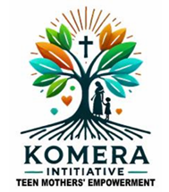

**Image**

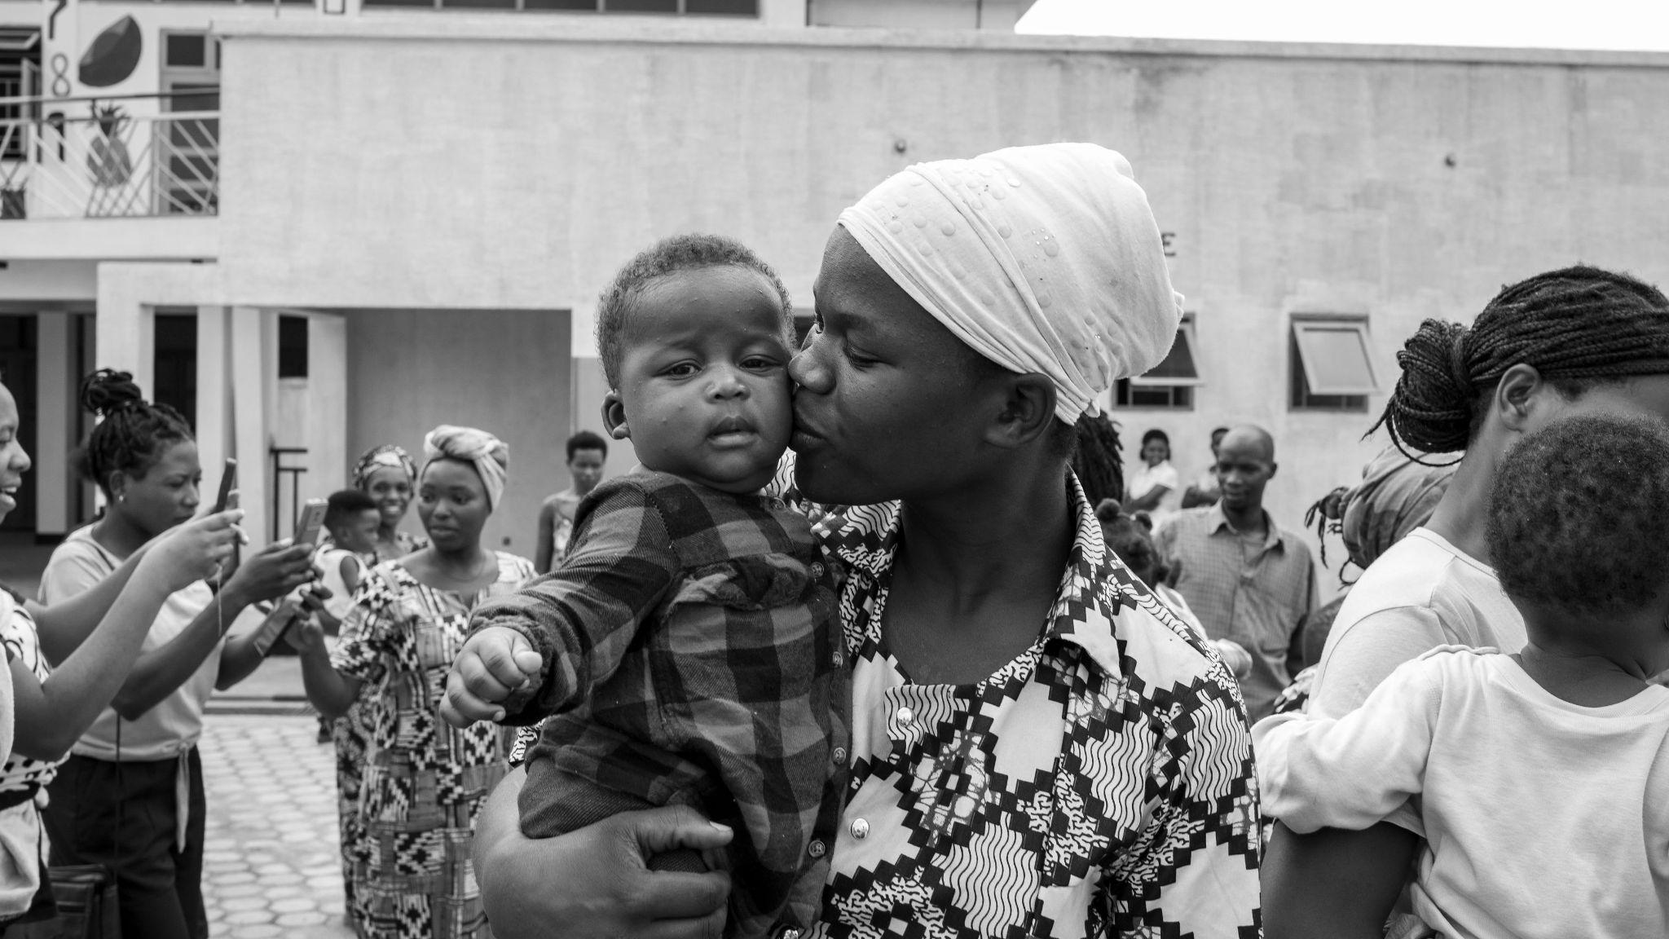

*One of our courageous mothers and her child during a Komera community day.*

### **💬 Sample Social Media Captions**

**Instagram / Facebook**

Meet the brave young moms of Komera Initiative — rewriting their stories with strength, support, and sisterhood.  
 📍Rwanda | 📚 Life Skills | 💪 Empowerment  
 👉 [komerainitiative.org](https://komerainitiative.org) #KomeraInitiative #TeenMomsRise #EmpowerRwanda

**LinkedIn**

At Komera Initiative, we believe every teen mom deserves a second chance at education, dignity, and opportunity. Join us as a donor or partner.  
 🔗 komerainitiative.org | 💌 contact@komerainitiative.org

**X (Twitter)**

Teen moms in Rwanda deserve more than stigma. They deserve skills, support & strength.  
 That's what Komera is about.   
 komerainitiative.org #KomeraInitiative

### **📍 Key Contacts**

* **General Inquiries**: contact@komerainitiative.org
* **Partnerships**: [komerainitiative.org/partner-with-komera](https://komerainitiative.org/partner-with-komera)
* **Donations**: [donorbox.org/support-komera-initiative](https://donorbox.org/support-komera-initiative)

### **🫶 Every Share Counts**

If you’ve downloaded this toolkit, thank you. That means you care about changing lives. Whether you’re a teacher, pastor, friend, influencer, or student — you can help raise awareness.

Let’s lift up the voices of teen mothers. Together.

**#KomeraInitiative** **#TeenMomsRise** **#HopeInAction**

🌍 komerainitiative.org | ✉ contact@komerainitiative.org | 💚 #KomeraInitiative