The formula for Bond price (PV) vs other factors is:
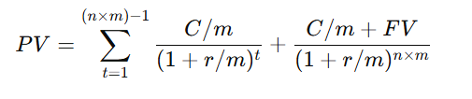
Where C is the annual coupon rate (percentage), m is periodicity (payments per year), r is annual discount rate in decimal number (or Yield to Maturity if the price is the same as PV), n is term to maturity in years, FV is Future Value that can be Face Value (Par) for Bullet bonds, 0 for Fully Amortized bond and something in between for partially Amortized (Balloon) bonds. Generally, PV and FV are percentage to par. C is also percentage.
When it is plotted, there is no intrapolation. Indeed the plot function just connected the dots to create a line.

