for interest and principal payment use the following formulas:
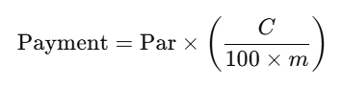
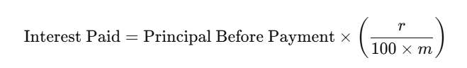
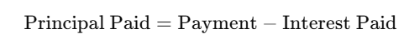
This formula is valid if C>r . Otherwise, principal paid will be negative which is not reasonable. You may create a graph of it, but it is not that mraningful.
The value of par for all graphs are 1000.

