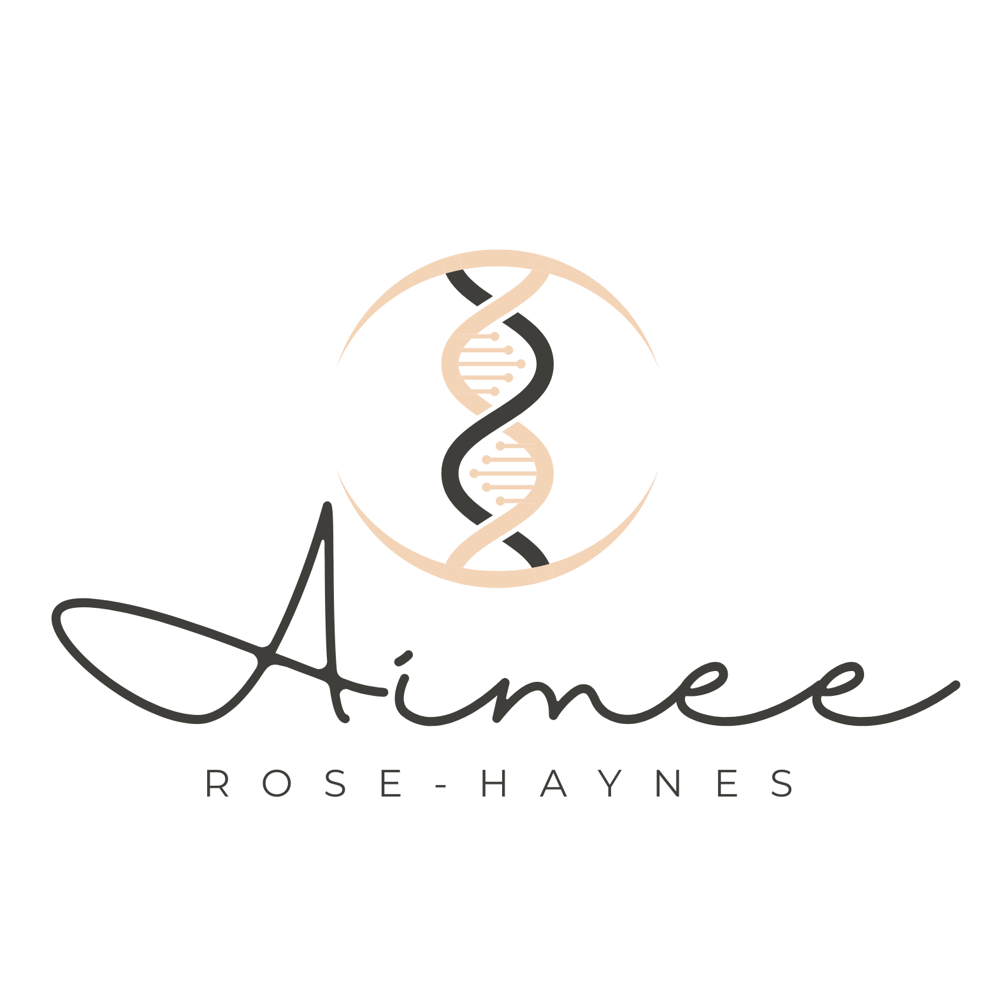

Genealogy Research Services Agreement
This Genealogy Research Services Agreement (Agreement) is entered into by and between Aimee Rose-Haynes (Genealogist) and the undersigned client (Client).
ETHICS
Genealogist will perform all work as an independent contractor in accordance with prevailing professional standards, including the Code of Ethics of the Association of Professional Genealogists, the Code of Ethics of the Board of Certification of Genealogists, and standards of the National Genealogical Society.
CONFIDENTIALITY
Client understands and agrees that Genealogist shall hold Client’s name, address, telephone number, and other identifying information in confidence unless Client authorizes release in writing. Genealogist shall also maintain confidentiality for all materials furnished by Client that contain:
- Information that is not a matter of public record or cannot be rightfully obtained from another nonconfidential source.
- Information that has not been independently developed by others.
- Information that Client has not disclosed to any other person or entity except under a strict, written confidentiality agreement that prevents further disclosure.
RESEARCH PROCESS AND REPORTING
After analysis and completion of research, a written summary report with findings and suggestions for further research will be provided if identified. Additional research requires prior written consent and is billed at the stated rate. All sources and pertinent information will be attached to your family tree. For DNA cases, DNA matches will be mapped within tree for applicable targeted line(s) when able to.
To avoid unnecessary duplication of work and related costs, you agree to provide me with all relevant materials you already possess relating to the person or family to be researched. This includes copies of prior research reports or summaries, significant records, and notes identifying sources, repositories, or record collections that have already been searched.
USE OF WORK
If findings are shared or published, they must be represented accurately with appropriate qualifiers (possible, suspected, probably) and credit given to this report.
CLIENT MATERIALS
Client agrees to provide all prior research and materials to avoid duplicate work.
TIME ESTIMATES
Some types of cases require more or less time depending on the available records and the complexity of the research question. Native ancestry suspect cases may take as little as three hours or as many as six hours, depending on the number of tribal rolls, Indian Census records, and related sources that must be reviewed. In these cases, I use documented family geographic information to focus research on specific tribes historically associated with the areas in which your family lived.
Most DNA related cases typically require between four and ten hours of research, though the exact time needed varies based on the number of relevant matches, the quality of available trees and records, and the overall complexity of the case. Some families are well documented, while others have few surviving records. This may result in a longer-term case. In situations where records are limited or unavailable, DNA evidence may play a larger role in confirming family lines.
The full scope of a project cannot always be determined until research has begun. As a result, time estimates are not guarantees, and some cases may require additional work beyond the initial hours contracted.
RESEARCH SCHEDULING
If you contract a project for a set number of hours, such as six hours, those hours may not be completed consecutively. I often achieve the best results by staggering research time over several days. Allowing time between research sessions can lead to new insights and more accurate conclusions as information is reviewed and reconsidered.
I am committed to being respectful of your time and your financial investment. If I reach a point at which meaningful progress is no longer possible, I will stop work immediately and notify you. While it may not always be possible to identify a specific individual, I can often identify the correct family line and provide guidance for moving closer to an answer.
Some ancestral origins, including but not limited to French Canada, Mexico, Puerto Rico, Ireland, Asia, and Africa, can present additional research challenges due to record availability and historical circumstances. I will make every reasonable effort to resolve these lines, but in some cases they may remain unresolved despite best efforts.
FEES AND PAYMENT
My professional fee is $99 per hour. All research is billed in increments of no less than three hours, with a maximum of six hours contracted and paid at one time. Payment for the full contracted time is due in advance and is required to secure your place on my wait list.
Once your project is scheduled, I will notify you by email before I begin active research so that you are aware I will be working within your family tree and associated research materials.
In rare circumstances, additional costs may be incurred. These costs may include, but are not limited to, court record copies, document requests, or repository fees. Any such costs will be discussed with you in advance whenever possible.
All payments are non-refundable. Refunds will not be given once payment has been made, as fees are charged for professional time reserved, research performed, and expertise applied.
Paypal: www.Paypal.me/aimeenhaynes
Venmo: Venmo.com/u/AimeeRoseHaynes
NO GUARANTEE OF RESULTS
You understand and agree that genealogical research involves many unknown factors and that specific results cannot be guaranteed. The availability and quality of historical records vary widely by time period, location, and jurisdiction. In addition, DNA based research depends on the availability, accuracy, and responsiveness of DNA matches, which are outside the control of the Genealogist.
Because of these limitations, it may not be possible to identify a specific individual or conclusively resolve a brick wall or unknown line. In some cases, research may identify only a probable or possible family line rather than definitive proof. By entering into this Agreement, you acknowledge and accept these inherent uncertainties and agree that fees are charged for time and professional effort, not for guaranteed outcomes.

Research Goal:

Additional Information:

Permission to share name and vague details with DNA matches:
(I am working with YOUR NAME and…. looking for family info, working on their family tree, looking to connect kind of messages to DNA matches to gain family names for your tree)
YES NO
By signing, you agree to the above contract
Client Signature: _________________________________________________
Client Name Printed: ____________________________________________
Client Email: _____________________________________________________
Date: __________________
Genealogist: Aimee Rose Haynes

