Weaponizing the Brain: Neuroscience Advancements Spark Debate
5/11/2017, By James Giordano
https://www.nationaldefensemagazine.org/articles/2017/5/11/weaponizing-the-brain-neuroscience-advancements-spark-debate
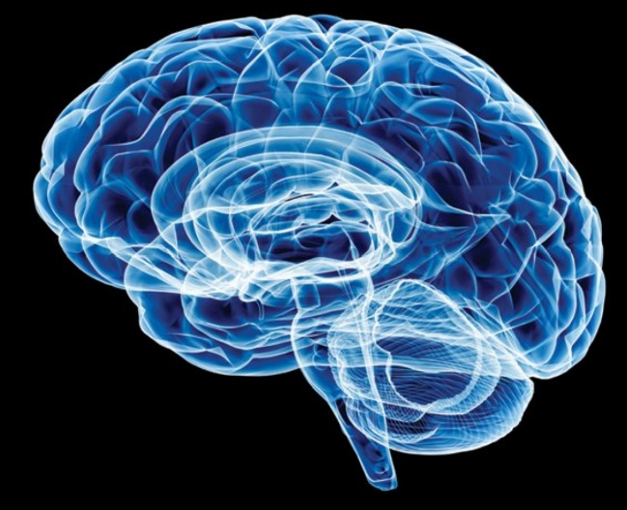

The rapid advancement of neuroscience and its corresponding technologies has prompted renewed and growing interest in both its development and the ethical concerns about the use of such techniques and tools in military and security contexts.
In 2008, the National Research Council of the National Academies of Science reported that the brain sciences showed potential for military and warfare applications, but were not yet wholly viable for operational use. However, by 2014, a subsequent report of the National Academies, “Emerging and Readily Available Technologies and National Security: A Framework for Addressing Ethical, Legal and Societal Issues,” concurred with a series of white papers by the strategic multilayer assessment group of the Joint Chiefs of Staff, and a 2013 Nuffield Council Report, stating that developments in the field had progressed to the extent that rendered the brain sciences viable, of definitive value and a realistic concern for the military.
This timeline is important, as it reflects the rapid and iteratively more sophisticated capability to create and exploit neuroscientific methods and technologies to access the brain, and assess and affect its functions of cognition, emotion and behavior.
Advancements in neuroscience could be used to create “super soldiers,” link brains to weapon systems for command and control, or even manipulate groups or leaders into taking actions that they normally wouldn’t do.
Obviously, new developments in brain science can be harnessed to improve neurological and psychiatric care within military medicine, and a number of ongoing Defense Department programs are doing so. The Defense Advanced Research Projects Agency, the Army Medical Research and Materiel Command and the Naval Bureau of Medicine and Surgery are generating new techniques and technologies for treating brain injury, neurodegenerative diseases such as Parkinson’s and Alzheimer’s disease, and certain psychiatric conditions, such as post-traumatic stress disorder and depression.
However, there is also considerable potential for dual-use applications of neuroscientific methods and tools that extend beyond the bedside. Many of these may reach battlefields.
These include the use of various drugs and forms of neurotechnologies such as neurofeedback, transcranial electrical and magnetic stimulation, and perhaps even implantable devices for training and performance optimization of intelligence and combat personnel. Brain-computer interfaces could be used to control aircraft, boats or unmanned vehicles. Military and warfare uses also entail the development and engagement of agents — such as drugs, microbes, toxins — and “devices as weapons,” also called neuroweapons, to affect the nervous system and modify opponents’ thoughts, feelings, senses, actions, health or — in some cases — to incur lethal consequences.
The use of neuroscience and technology to optimize the performance of military personnel could potentially lead to the creation of “super soldiers.” This remains a provocative and contentious issue.
When viewed in a positive light, such approaches could — and arguably should — be employed to prevent warfare. For example, intelligence and military personnel who have increased cognitive, emotional and/or behavioral capacities might be able to more easily and capably detect threats, function under arduous conditions with less stress, and have increased sensitivity to socio-cultural and physical cues and nuances in foreign environments. They could be more effective in reducing the risk of violence.
These goals led to efforts such as the Intelligence Advanced Research Projects Activity’s Sociocultural Content in Language program and the Metaphor program, which both sought to improve insight into cultural linguistic and emotional norms. DARPA’s Narrative Networks program aimed to utilize neurocognitive science and technology to improve narratives in socio-cultural contexts.
On the other hand, there are concerns for the negative effects that the field might have on “neuro-modified” individuals’ health. There is trepidation about using such approaches to turn warfighters into amoral, combative automatons and questions about what responsibilities and burdens might be incurred for — and borne by — the military, and perhaps society at large, when dealing with such effects.
But while such questions and concerns may suggest the need for a reflective pause, it’s important to note that brain research and its corresponding technologies are becoming ever more international, and a number of countries such as China and Russia, and some U.S. allies, are engaged in these pursuits and are interested in their military viability and use. This creates a situation that tends to sustain, if not advance the pace and extent of research, development and incorporation of neuroscience and technology in intelligence and military initiatives.
The internationalization of brain science, taken together with the speed of its progress, fosters additional concerns about the development and use of neuroweapons.
While existing international agreements on biological and chemical weapons such as the Hague Conventions, Geneva Protocol and the Biologic, Toxin and Weapons Convention limit institutional research, stockpiling and international trade of certain toxins and neuro-microbiologicals such as ricin and anthrax, some neurobiological substances and technologies developed for medical products that are readily available on the commercial market might not fall within existing international rules.
"Advancements in neuroscience could be used to create ‘super soldiers.'"
These include neurotropic drugs created in pharmaceutical labs, bio-regulators — defined as substances that affect biological processes, such as opioids and other peptides — and neuromodulatory technologies such as transcranial or deep brain stimulating devices.
And, as noted in the 2008 National Academy of Sciences report, products intended for the health market can — and frequently are — studied and developed for possible employment in military applications. In the United States, any such activity in federally funded programs would be subject to oversight in accordance with dual-use policies, reflecting the general tenor of current international biological and chemical weapons conventions.
But that leaves a gap that foreign governments could exploit using health research as a veil to pursue new military neuroscience and technology, and shielding their activities behind commercial norms protecting proprietary interests and intellectual property.
A further concern is that neurobiological and neurochemical substances and certain neurotechnologies can be obtained or developed with relative ease by non-state actors. Of note is a growing worldwide community of “black hat” do-it-yourself biohacker scientists, who may be supported by state-endorsed venture capital with explicit intent toward disrupting public safety, stability and health; and who may operate without regard for regulations defined by current signatory treaties and conventions.
The increasing availability of tools for DIY neurobiology, such as gene-editing kits that can be employed to genetically modify existing microbes and toxins and make them more potent or lethal, increases the probability of both their use, and attendant risks and threats that such techniques and their products pose to national security.
Former Director of National Intelligence James Clapper stated last year that gene editing should be regarded for its potential for creating biological weapons.
The impact of neuroweapons is equally important to consider. While nerve agents such as sarin, or pathogens such as anthrax, can induce somewhat widespread effects, other, more sophisticated neuroweapons should not be regarded as weapons of mass destruction, but rather as “weapons of mass disruption,” often with subtle, albeit intensifying effects.
For instance, neurologically acting drugs can be used to selectively target the thoughts, sentiments and actions of an individual, such as a political or military leader, to evoke a change in his or her ideas, emotions and behavior. This could exert effect on those they lead, influencing their views and actions toward either conformity or dissonance.
Certain neuroactive drugs, toxins and/or microbes can also be used against larger scale targets to incur “ripple consequences” within a group, community or population. For example, these agents could be dispersed to produce “sentinel cases” of individuals who exhibit neuro-psychiatric and other physical signs and symptoms. Attribution as a terrorist action, and accompanying misinformation about salient and escalating signs and symptoms — such as anxiety, sleeplessness and paranoia — could be propagated over the internet.
This would tend to amplify reactions among an expanding number of members of the group or population, who would then seek health care, and thereby evoke an increasing burden on the public health system — even if only in the short term.
Subsequent internet messaging of narratives aimed at denigrating any governmental responses in attempting to quell public concerns and reaction to the “threat,” could be used to both foster dissolution of public trust, and increase widening social disruption. One need only to recall the public response to the very limited distribution of anthrax in the weeks following the 9/11 attacks for evidence of the viability and possible effects of such tactics.
To be sure, brain science is not the only venue for the development of new tools and weapons. Yet, it confers powerful capabilities to affect “minds and hearts” and therefore affords clear and present leverage in military and warfare operations.
Recognition and a realistic appraisal of these capabilities — and its limits — are crucial steps to readiness and response. In these times of rapidly reduced budgets and limited resources, it thus becomes ever more important to accurately estimate the relative benefit, burden, risks and threats that specific types and applications of neuroscience and technology will incur, and to develop and maintain a proactive posture to ensure the possibilities for these developments both now and in the future.
James Giordano, PhD, is a professor in the Departments of Neurology and Biochemistry, chief of the Neuroethics Studies Program and co-director of the O’Neill-Pellegrino Program in Brain Science and Global Health Law and Policy at Georgetown University Medical Center, Washington, D.C. His latest book is Neurotechnology in National Security and Defense: Practical Considerations, Neuroethical Concerns. The views expressed in this essay do not necessarily reflect those of the EU Human Brain Project, DARPA, the Joint Chiefs of Staff, or the Defense Department, all of which he has served as an advisor.

