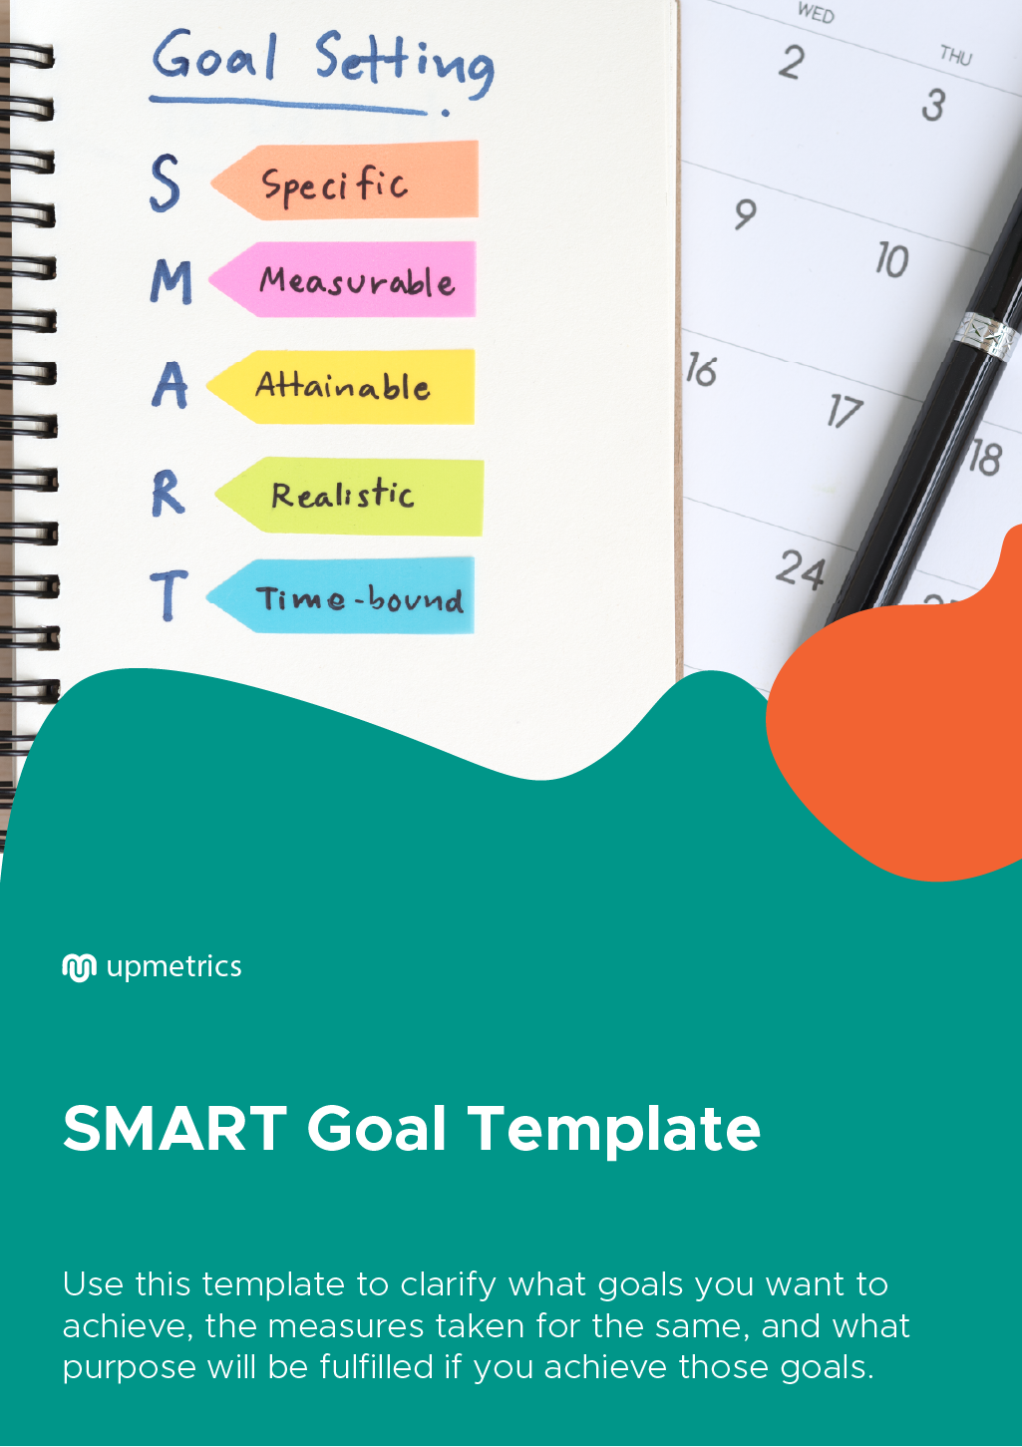

| **Hi There!**  Thanks for downloading this template.    You Can Edit Version To Fit Your Needs. |
| --- |
| How to use a SMART goal template?  Creating SMART goals is one of the best strategies to take steps towards achieving your goals. It helps you create goals that are more specific and achieve them faster.  Here’s how this template can help you:   1. It will help you set specific goals. 2. It will help you select metrics for tracking the progress of your goals. 3. Your goals will be realistic and have a purpose. 4. It will help you set a timeline for achieving your goals.   Setting proper goals can help your business grow in an optimum way. Moreover, SMART can help you set goals in a better way. |

| Do you want to plan your business faster?  Upmetrics can help you at every step of writing your business plan.  So, what are you waiting for! | Sample Business Plan |
| --- | --- |
| [**Start writing your business plan today**](https://upmetrics.co/call-to-download?utm_source=smart-goals-template&utm_medium=create-business-plan&utm_campaign=download)**!** | |

**S.M.A.R.T Goal Template**

|  |
| --- |
| **Specific – WHO? WHAT?** |
| **Measureable – HOW?** |
| **Attainable– REASONABLE?** |
| **Relevant – EXPECTED RESULT?** |
| **Timed Oriented – WHEN?** |

**S.M.A.R.T Goal Example**

|  |
| --- |
| **Specific**  I will increase my revenue by cutting down expenses and operational costs by moving to an affordable place. |
| **Measureable**  I will take up new projects and take new clients in the next 6 months. I will review my finances monthly to track progress. |
| **Attainable**  I will create new leads through promotion by referrals, social media, and brand networking, thereby increasing revenue through new clients. |
| **Relevant**  Relocation to a cheaper office will reduce costs, which I can further invest in marketing, contributing towards achieving the goal. |
| **Timed Oriented**  My profits should have increase by the end of 6 months. I will set milestones to help me stay focused and motivated to achieve the goal. |