
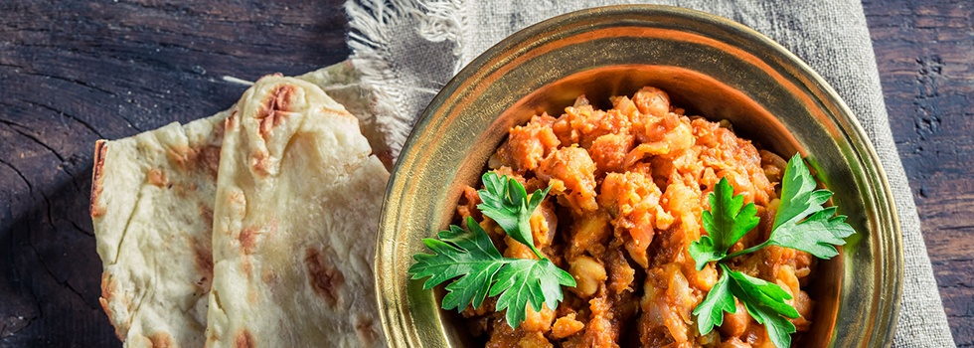
- Resources
Ayurvedic Food Combining: Principles to Balance Doshas & Digestion
- August 24, 2021
by Usha and Vasant Lad, BAM&S, MASc

It is no surprise to see on the market today so many digestive and dietary aids for the stomach, along with pills for gas and indigestion. Most of these conditions likely begin with poor food combining. This is a subject of much debate amid the growing

concern about diet and the many theories on the topic.
Ayurveda, an ancient holistic science of healing, offers a logical approach for determining correct diet based upon the elements comprising an individual’s constitution: vata, pitta and kapha. This approach is quite different from the contemporary view of a balanced diet, based on eating from various food groups. Ayurveda believes that understanding the individual is the key to finding a truly balanced diet. It teaches that the gastric fire or agni in the stomach and digestive tract is the main gate through which nutrients enter the tissues and then pass along to individual cells, to maintain the life functions.
According to Ayurveda, every food has its own taste (rasa), a heating or cooling energy (virya) and a post-digestive effect

(vipaka). Some also possess prabhava, an unexplained effect. So while it is true that an individual’s agni largely determines how well or poorly food is digested, food combinations are also of great importance. When two or more foods having different taste, energy and post-digestive effect are combined, agni can become overloaded, inhibiting the enzyme system and resulting in the production of toxins. Yet these same foods, if eaten separately, might well stimulate agni, be digested more quickly and even help to burn ama.
Poor combining can produce indigestion, fermentation, putrefaction and gas formation and, if prolonged, can lead to toxemia and disease. For example, eating bananas with milk can diminish agni, change the intestinal flora, produce toxins and may cause sinus congestion, cold,

cough and allergies. Although both of these foods have a sweet taste and a cooling energy, their post-digestive effect is very different – bananas are sour while milk is sweet. This causes confusion to our digestive system and may result in toxins, allergies and other imbalances.
Similarly, milk and melons should not be eaten together. Both are cooling, but milk is laxative and melon diuretic. Milk requires more time for digestion. Moreover the stomach acid required to digest the melon causes the milk to curdle, so Ayurveda advises against taking milk with sour foods. These incompatible food combinations not only disturb the digestion but also cause confusion in the intelligence of our cells, which can lead to many different diseases.
Before you say “This is MUCH too complicated, how will I ever figure it out?”,

there are some useful guidelines to introduce you to these concepts. And remember that Ayurveda is a strong proponent of the “go slowly” school of thought.
You might want to introduce yourself to food combining by eating fruit by itself, as many fruits create a sour and indigestible “wine” in the stomach when mixed with other food. Once you have adopted this change into your eating habits, try other suggestions from the list below. As a general principal, avoid eating lots of raw and cooked foods together or fresh foods with leftovers.
Various Factors that Can Lessen the Effects of Bad Food Combinations
- A strong digestive fire (if we are so blessed) can be the most powerful tool

of all to deal with “bad” food combinations.
- Different quantities of each food involved in a combination can sometimes help significantly. For instance equal quantities by weight of ghee and honey are a bad combination—ghee is cooling, but honey is heating—whereas mixing a 2:1 ratio is not toxic. The reason? Prahbav, the unexplainable.
- Very often spices and herbs are added in Ayurvedic cooking to help make foods compatible or to ease a powerful effect, e.g., cooling cilantro in very spicy food.
- If our bodies have become accustomed to a certain food combination through many years of use, such as eating cheese with apples, then it is likely that our body has made some adaptation or

become accustomed to this. Which is not to say that we should continue this practice, but to explain why the newcomer to apples and cheese may experience a strong case of indigestion whilst the “old-timer” digests it adequately.
- Antidotes, like cardamom in coffee, or ghee and black pepper with potatoes, often can help alleviate some of the negative effects. (Coffee is stimulating and ultimately depressing to the system, and potatoes cause gas).
- If foods with different and possibly aggravating qualities, such as a mixture of vegetables, are cooked together in the same pot, the foods tend to learn how to get along. Using appropriate spices and herbs helps with this too.
- Eating a ‘bad’ combination occasionally

usually does not upset the digestion too much.
Some Useful Tips to Aid Digestion
- Eat ½ teaspoon fresh grated ginger with a pinch of rock salt before each meal to stimulate agni.
- Salt also aids digestion, and helps to retain water.
- Alkalis help digestion and regulate gastric fire.
- Ghee stimulates agni and improves digestion.
- Small sips of warm water during a meal will aid digestion and absorption of food. Do not drink iced water as it slows agni and digestion. Indeed ice water should not be taken under most circumstances, as it is too shocking to the system.

- Proper chewing is essential to good digestion, ensuring food gets thoroughly mixed with saliva.
- A cup of lassi at the end of a meal also aids the digestive process. Make by blending ¼ cup yogurt with 2 pinches of ginger and cumin powder in 1 cup water.
- Ideally, one should fill the stomach with one-third food, one-third liquid and one-third should be empty.
The following table lists some* of the incompatible food combinations worth avoiding.
DON’T EATWITHBeansfruit; cheese, eggs, fish, milk, meat, yogurtEggsfruit, especially melons; beans, cheese, fish, kitchari, MILK, meat, yogurtFruitAs a rule, with any other food. (There are exceptions, such as certain cooked combinations, as well as dates and milk, which have the same rasa,

virya and vipaka.)Grainsfruit; tapiocaHoney**With equal GHEE by weight (e.g. 1 tsp. honey with 3 tsp. ghee); boiled or cooked honey.Hot Drinksmangos; cheese, fish, meat, starch, yogurtLemoncucumbers, milk, tomatoes, yogurtMelonsEVERYTHING – especially dairy, eggs, fried food, grains, starches. Melons more than most fruit should be eaten alone or left alone.MilkBANANAS, cherries, melons, sour fruits; bread containing yeast, fish, kitchari, meat, yogurtNightshades, e.g., potato, tomatomelon; cucumber, dairy productsRadishesbananas, raisins; milkTapiocafruit, especially banana and mango; beans, raisins, jaggaryYogurtfruit; cheese, eggs, fish, hot drinks, meat, MILK, nightshades
*Foods in CAPITALS are the most difficult combinations.

**According to ancient Ayurvedic literature, honey should never be cooked. If cooked, the molecules become a non-homogenized glue that adheres to mucous membranes and clogs subtle channels, producing toxins. Uncooked honey is nectar. Cooked honey is considered poison.
© 1997, 2016. Amended extracts reprinted with permission from: Ayurvedic Cooking for Self-Healing by Usha and Dr. Vasant Lad, 1997.

Vasant Lad BAM&S, MASc
A native of India, he served for three years as Medical Director of the Ayurveda Hospital in Pune, India. He was Professor of Clinical Medicine at the Pune University College of Ayurvedic Medicine for 15 years. He holds a Bachelor’s of Ayurvedic

Medicine and Surgery (BAM&S) degree from the University of Pune and a Master’s of Ayurvedic Science (MASc) degree from Tilak Ayurved Mahavidyalaya. The author of numerous books, Vasant Lad is respected throughout the world for his knowledge of Ayurveda

