The Writer, July 25, 2025
Dear Writer
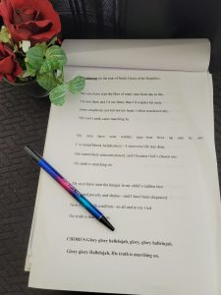
By Nina Ward

Dear Writer,
Your words can slash a person’s heart like the strength of a tiny diamond that can cut through glass and steel. Whether you are a published author or write for enjoyment, your words have a purpose.
Will you deny your talent and keep those words concealed, words wanting to erupt from your inner being? Or will you release to the universe for others to be entertained, healed, or guided?

Writer,
Occasionally, I find myself wondering why I write. Who is listening? Then, I remember a time…
One day, a woman in my apartment complex crossed my path. I wondered why this woman whom I scarcely knew, felt the need to vent her frustration about the horrible crisis she found herself in. The familiar situation happened to be the topic of an article I was writing about. I could not think of any way to help her except to hand her a copy of my finished, but unpolished manuscript. After covering the three-page script in a little prayer, I handed the words over with the hope it would direct her to a better understanding of the predicament and offer steps to take toward victory.
Weeks later, she knocked on my door, handed me a plate of cookies and repeatedly thanked me for the words. The article sold to three different magazines over the years, but those hefty payments I earned will never compete with the gratitude of this woman. Those earnings are gone, but the smile and tears on her face remain in my memory. You may never know who felt the touch of written words from your hand. This is not why we write. It’s an added joy when we read our work to an audience and see the reaction in an expression of horror, a smile of hope, or a tear in an eye. But this is not why we write. Writer, We write because we have something to say. “There is not greater agony than bearing an untold story inside you” Maya Angelou *** Nina Ward is a published fiction and nonfiction author in print and digital publications. She is one of the founders and facilitators of the Florida Gulf Coast Writers Circle. When she is not writing, you can find her and her ukulele embracing a beach sunset.

