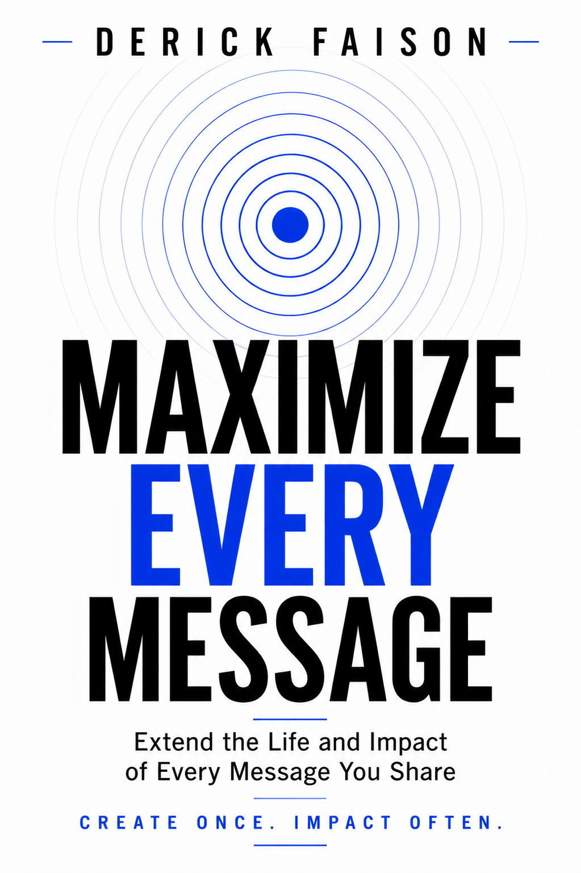
MAXIMIZE EVERY MESSAGE
Extend the Life and Impact of Every Message You Share

Create Once. Impact Often.
Derick Faison
MAXIMIZE EVERY MESSAGE
Extend the Life and Impact of Every Message You Share
By
Derick Faison

Copyright

Copyright © 2026 Derick Faison. All rights reserved. No part of this publication may be reproduced, stored, or transmitted in any form or by any means without written permission from the publisher, except for brief quotations used in reviews or scholarly works.
Maximize Every Message™, The Legacy Content System™, Legacy Content Starter Kit™, L.E.A.D. Academy™, The Growth Path™, and Create Once. Impact Often. are trademarks or brand identifiers of Derick Faison.
Published by Derick Faison Leadership
www.derickfaison.com
First Edition

Every message has the power to change a life.
The question is...
Does its influence end when you stop speaking?

Every Message Has the Power to Change a Life

A sermon can strengthen someone's faith. A keynote can inspire a new direction. A lesson can unlock understanding. A single conversation can change the course of someone's future. That's the power of a message.
But too often, its influence ends the moment it’s delivered. We move on to the next sermon. The next presentation. The next workshop. The next opportunity.
Without realizing it, we leave behind ideas that still have the power to encourage, teach, and inspire. What if your greatest opportunity isn't your next message? What if it's the one you've already shared?
That's the idea behind Maximize Every Message™. It isn't about creating more. It's about allowing your message to continue making a difference.

Don't just deliver your message. Maximize it!

Your Message Has More to Give

In the next few pages, you'll discover why...
• Great messages often disappear too soon.
• Familiarity causes leaders to overlook their own best work.
• One message can continue serving people long after it was first delivered.
• Moving on too quickly leaves influence behind.
• A simple shift in perspective changes everything.
You’ll also discover why The Legacy Content Starter Kit™ is the natural next step.

One message can continue making a difference...long after it's first delivered.

Most Messages End Too Soon

Most leaders don't have a message problem. They have a visibility problem. A message is shared. People are encouraged. Then everyone moves on. We've been conditioned to believe that once the audience leaves, the work is finished.
But what if that's only the beginning? Great messages don't lose their value because they're old. They lose their value because they're forgotten.
Maybe your next opportunity isn't waiting in your next message. Maybe it's waiting in the one you've already shared.

Great messages don't lose their value. They lose their visibility.

Familiarity Hides Value

Most leaders underestimate the value of their own message. Not because it lacks significance. But, because they've lived with it for so long. The sermon you've preached several times. The leadership lesson you've taught for years. The story you've shared countless times.
To you, it feels familiar. To someone hearing it for the first time, it can be transformational. That's the danger of familiarity. We stop seeing the value because we've become accustomed to it. Never assume your message has lost its power simply because you've heard it before.
The people you're called to serve haven't lived your journey. They haven't learned what you've learned. They haven't heard what you've shared. Your message may be ordinary to you. It may be exactly what someone else has been praying for.

What feels ordinary to you... may be extraordinary to someone else.

The Principle in Action

One message can become far more than a moment. One of the clearest examples is Woman, Thou Art Loosed! By T.D Jakes. What began as a single message grew into books, conferences, Bible studies, films, and a movement that impacted millions of lives. The message didn't end. It continued.
The same principle changed the way I viewed my own work. I originally taught, The 5 Habits of High Impact Men during a men's gathering at our church. After the session, several men asked if the material was available in writing so they could revisit it and share it with others.
That simple question changed my perspective. I realized the message didn't have to end when the meeting ended. It could continue serving men long after the event was over. That realization eventually became a book and opened the door to additional leadership resources built from the same message.

The message didn't change. My perspective did.

A Missed Opportunity
Many leaders just “move on” from great messages. Eager to get to the next message. Every time we move on too quickly, we leave something behind. Not just another message. Another opportunity. An opportunity to encourage someone who wasn't in the room. To reach a different audience. To continue serving people who still need what you've already shared.
Many leaders believe they need another great idea. Often, they simply need another look at the one they already have. Your greatest opportunity may not be waiting in next week's message. It may already exist in last week's.

"Don't mistake moving on for moving forward."

Think Differently

Every meaningful change begins with a new way of thinking. For years, I believed success meant creating my next message. Now I believe something different.
The greatest opportunity isn't always in creating something new. Sometimes it's in seeing something familiar with fresh eyes. That's the shift behind Maximize Every Message™. When you stop asking,
"What's my next message?"
and start asking,
"How can this message continue making a difference?"
everything changes.
Your influence grows. Your message reaches further. Your work continues long after you've stepped away from the platform. You don't need more ideas. You need a new perspective.

The opportunity isn't in your next message. It's in seeing your last message differently.

The Journey Begins Here

If this guide changed the way you think about your message, don't let the journey stop here. The Legacy Content Starter Kit™ is designed to help you begin extending the impact of the messages you've already shared.
Inside, you'll discover practical tools to help you identify opportunities, organize your ideas, and maximize every message you share. It's the perfect place to begin.

Ready to Continue? Begin with the Legacy Content Starter Kit™
Visit: www.derickfaison.com

Don't just deliver your message. Maximize it.

Meet the Principal Instructor

Derick Faison is passionate about helping leaders grow personally, lead effectively, and extend their influence.
As a pastor, speaker, author, and leadership development coach, he equips pastors, speakers, authors, coaches, and leaders with practical principles that create lasting impact.
He is the creator of The Legacy Content System™, founder of L.E.A.D. Academy™, and developer of The Growth Path™—a leadership ecosystem designed to help leaders maximize every message they share.
Whether speaking, writing, coaching, or creating leadership resources, his mission is simple:
Helping leaders maximize every message they share.

Continue Your Leadership Journey.
BEGIN with the Legacy Content Starter Kit™
GROW through L.E.A.D. Academy™
ADVANCE along The Growth Path™
www.derickfaison.com
Live Better. Lead Better.

