
FOR IMMEDIATE RELEASE

Press release date: March 04, 2026
Contact: Jaime Maria Merill
Publisher: Murmuration
Email: jaimemariamerrill@jaimeswords.com
Website: jaimeswords.com

Through One Girl’s Journey Of Self-Discovery, Author Explores How A Single Voice Can Create Change, Even In The Face Of Overwhelming Odds
A new novel for middle-grade readers invites discussion of resilience and courage.
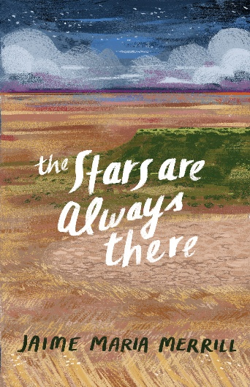
[WASHINGTON, D.C.] – Publishing group Murmuration announces the release of a new middle-grade literary fiction novel for young readers. The Stars Are Always There, written by Jaime Maria Merrill, is a moving story of one girl’s journey of isolation and self-discovery on the arid high plains of Texas.

In Merrill’s story, twelve-year-old Jess Lindsey never imagined spending her entire summer on the dusty Texas Panhandle. But when she arrives at her great-grandfather’s ranch, Jess discovers the land itself is in trouble.

With a wealthy farmer pumping more water than the earth can spare, wells run dry, tempers flare, and something strange stirs on the prairie. The animals are trying to tell Jess something, the wind is listening, and the stars feel closer than normal.

As she uncovers the ranch’s secrets, Jess must decide who she wants to be—quiet and careful like always, or brave enough to speak up when it matters most. With a loyal horse, a few unlikely allies, and a touch of prairie magic guiding her, Jess sets out to protect the place that’s starting to feel like home.

With themes of overcoming adversity, personal growth, and interconnectedness with the natural world around us, families and educators of young children will welcome an opportunity to invite topical discussion. Harnessing her own vivid childhood memories, author Jaime Maria Merrill brings an evocative authenticity and tenderness to her debut novel. The Stars Are Always There is available now wherever books are sold.

###

For more information about the author or book or to request a review copy, contact Jaime Maria Merrill at jaimemariamerrill@jaimeswords.com or visit www.jaimeswords.com.

