Welcome to Doris Diaries
Life has a funny way of changing when we least expect it.
For Doris Kaminski, those changes began after the loss of her beloved husband, Harold. Suddenly, everyday tasks that once seemed simple felt unfamiliar, and the quiet moments in her little yellow Victorian house became much louder than she ever imagined.
But Doris soon discovers that even after loss, life still has surprises to offer. With the help of good friends, kind neighbors, and her faithful beagle, Biscuit, she begins to find laughter, purpose, and confidence again—one small step at a time.
Doris Diaries is a collection of heartwarming stories about friendship, resilience, and the courage to embrace new beginnings at any age. Along the way, Doris learns practical lessons about modern life—from managing finances and technology to staying connected with family and community—all while reminding us that it's never too late to learn something new.
Whether these stories make you smile, bring back a memory, or help you through a challenge of your own, I hope you'll feel as though you've spent time with an old friend.
So, pour yourself a cup of coffee or tea, settle into your favorite chair, and join Doris on her journey.
Welcome to Doris Diaries. We're so glad you're here.
Heartwarming stories of friendship, resilience, and finding joy in life's next chapter.



Chapter One

The Jar, the Ladder, and the Nice Young Man Next Door
Doris Kaminski had counted fourteen casseroles in the three weeks since Harold's funeral: tuna noodle, chicken and rice, something with cream of mushroom soup that she suspected came from a can but ate anyway because it was warm and someone had made it for her. The neighbors meant well. The church ladies meant well. Everyone meant extremely, exhaustingly well.
And then, as if by some unspoken agreement, the casseroles simply stopped. The phone calls thinned. The sympathy cards on the mantel began to curl at the corners.
Harold had been gone eleven weeks now. The world, apparently, had decided that was long enough to grieve.
Doris had not gotten that memo.
She was seventy-eight years old, five-foot-two on a good day, and the yellow house on Clover Street—their house—had never once felt so large. She had rearranged the bedroom furniture twice, trying to make it feel less like a room with something missing from it. It still felt like a room with something missing from it.
Harold's recliner was still in the living room. Linda had offered to haul it away during her last visit. Doris had said she'd think about it, which was her way of saying absolutely not yet.
She was of the firm opinion that asking for help was something you did only after exhausting every other option. Harold used to say she'd argue with a stop sign. He hadn't been wrong.
Today's challenge was the pickles.
A jar of Claussen dill pickles sat on the top shelf of the pantry, placed there by her daughter Linda during last month's 'helpful' visit. Linda had reorganized the kitchen 'for efficiency,' which apparently meant putting everything Doris used daily on the highest shelf possible.
Doris needed a pickle. She needed it very much. Egg salad simply could not happen without dill pickles. Linda had suggested relish, as though that were a perfectly reasonable thing to say.
She glanced at Harold's photograph on the refrigerator. "I am a grown woman," she said aloud. "I have earned the right to my own pickles."
He would have gotten them without being asked. That was the thing nobody warned you about. Not the big losses.
The small ones.
She retrieved the ladder. It was perfectly safe, and Doris had used it a hundred times. She climbed the first step, then the second, reaching carefully for the jar.
She had it. Cold glass. Beautiful. Triumphant.
And that was when Biscuit chose to sneeze directly against the back of her ankle.
Doris did not fall.
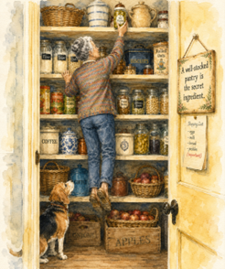
She would like that on the record.
She did, however, end up hugging the pantry shelf with a jar of pickles pressed against her collarbone.
It was in this position that she heard a knock at the back door.
"Mrs. K?" called a familiar voice. "I saw your light on. I've got your mail... are you okay in there?"

That was Marcus, the kind young man next door. He brought tomatoes from his garden without being asked, which Doris considered the mark of a genuinely good person.
"I'm fine!" she called.
A pause.
"Are you... in the pantry?"
"...Possibly," Doris admitted.
Marcus stepped into the pantry. To his great credit, he did not laugh. "May I?" he asked, reaching for the jar.
"You may," Doris said after weighing her dignity against the pickles.
He set the jar on the counter and offered his arm as she stepped down. Biscuit sneezed again.
"Egg salad?" Marcus guessed.
"Egg salad," Doris confirmed.
"My grandmother made it with dill pickles too. Relish is not the same thing."
"You," Doris said, pointing at him, "are a very intelligent young man."
She made enough egg salad for two.
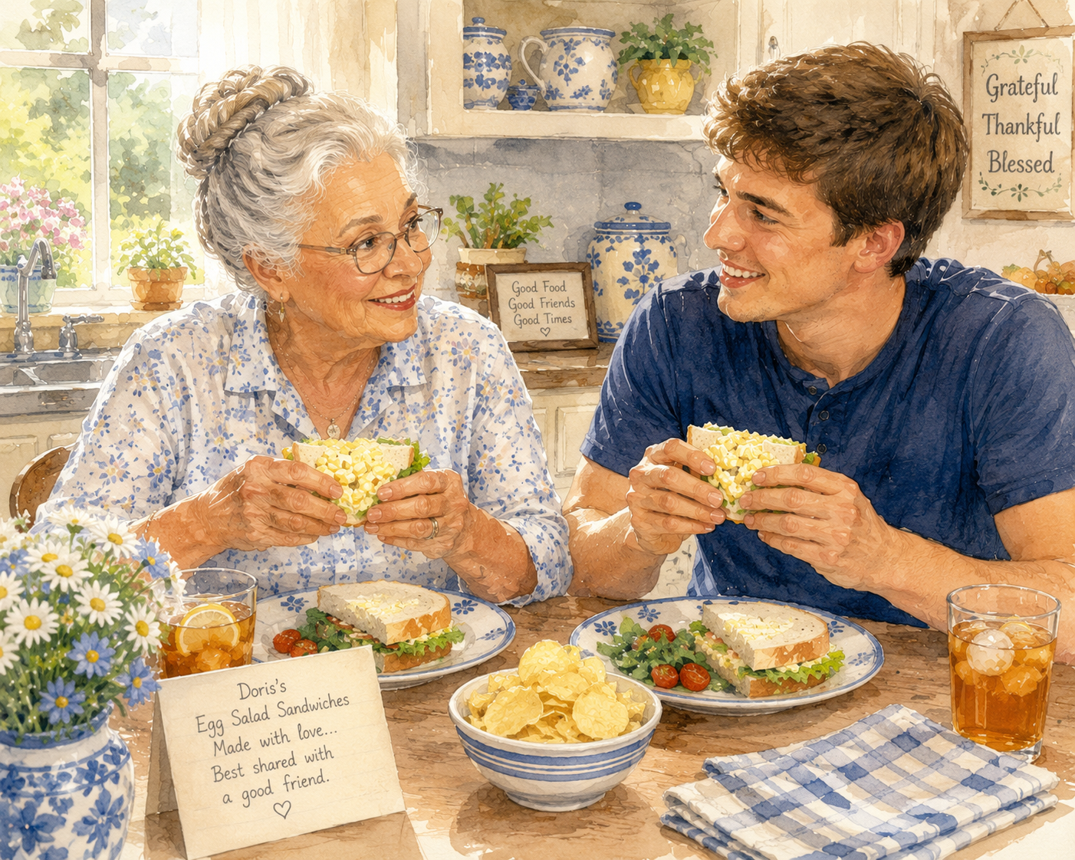
Over lunch Doris learned that Marcus worked from home, lived alone, and had not spoken to anyone in person for several days. Marcus learned that Doris had once played semi-pro softball, hated the word 'moist,' and had very strong opinions about the designated hitter rule.

It was, she thought, a perfectly fine Tuesday.
Later, while washing dishes, Doris glanced toward the pantry shelf and then at Harold's photograph. She wondered how much longer the old yellow Victorian was going to feel manageable. It had always been the two of them—Harold on the ladder, Doris handing things up.
Now it was just her.
And a beagle who sneezed at critical moments.
Linda had been dropping hints about 'a really lovely community' twenty miles away. Doris ignored those hints with Olympic-level focus. This was Harold's house. Her house. The elm tree in the backyard had grown up with their family.

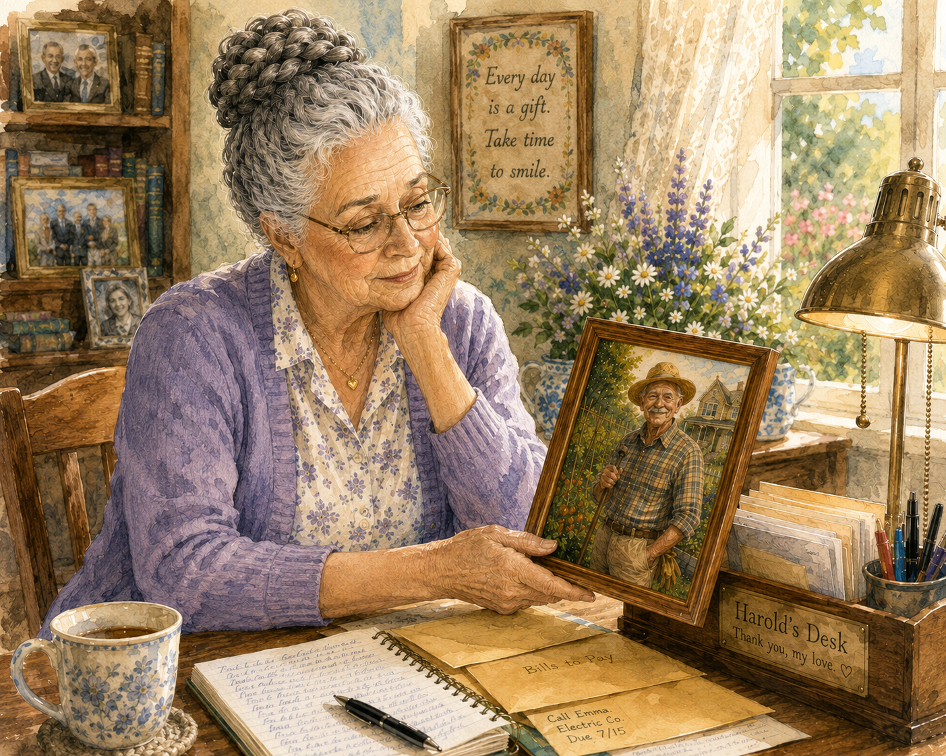
She dried her hands and looked at Harold's picture once more.
"Not yet," she said.
Same as she said every night.
But this time, when she put the stepladder away, she left it just a little closer within reach.

Next Month in Doris Diaries
Doris receives a letter—not from Linda, and not a bill. The return address is from a town she hasn't thought about in forty years, and from a name she once promised herself she'd never look up again.
© Doris Diaries. Reproduction or reprint is prohibited without permission. For reprint permissions, contact Kathleen O'Neal.

