SIMULADO DE INGLÊS
Escola:
Professor (a): | Data:____/_____/______
Estudante: | Turma:
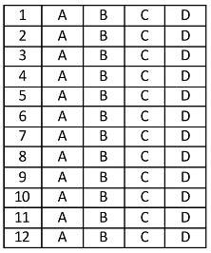

Leia o texto abaixo e responda as questões 01, 02 e 03.

Positive Messages from Kids Make Hotline¹ a Hit

Students at an elementary school in California, with the help of their art teacher, created a telephone hotline¹ that people can call to get cheerful advice² from kids during difficult times. In just days, the hotline began getting thousands of calls an hour.
The hotline is available in English and Spanish. It offers the happy voices of children of different ages sharing positive messages. For example, by pressing 3, you can hear a group of kindergartners³ saying together: “You can do it! Keep trying, don’t give up!” Pressing 4 triggers the sounds of children giggling⁴ and laughing — a sound certain to bring a smile to anyone’s face. [...]
Jessica Martin, who teaches art at West Side School in Healdsburg, California, thought her students just might have the magic words needed to bring calm to people [...]. “To hear the pure joy from kids is extremely comforting,” she says.
Ms. Martin, along with artist Asherah Weiss, worked with students at West Side on a project they called “PepToc”. Actually, they called it “Pep Talk” first. But when Ms. Martin’s 6-year-old son drew an ad for the hotline and spelled it “PepToc”, they decided they liked that even better.
The project had two parts — one was the hotline, and the other was creating encouraging posters. Most of the project was completed in a day. The two adults worked with students from Kindergarten to sixth grade. They had the same basic question for all the students: “What could you say to help or encourage someone else?” [...]
*Vocabulário:
¹hotline: linha direta.
²cheerful advice: conselhos alegres.
³kindergartners: crianças do jardim de infância.
⁴giggling: rindo.

NEWS FOR KIDS. Positive Messages from Kids Make Hotline a Hit. 2022. Disponível em: https://bit.ly/3y9WStf. Acesso em: 4 maio 2022. Fragmento.

D Questão 01 –––––––––––––––––––––––––––◊
A informação principal desse texto está no trecho:
A) “Students at an elementary school in California, with the help of their art teacher, created a telephone hotline that people can call to get cheerful advice from kids during difficult times.”. (1º parágrafo)
B) “For example, by pressing 3, you can hear a group of kindergartners saying together: ‘You can do it! Keep trying, don’t give up!’”. (2º parágrafo)
C) “Jessica Martin, who teaches art at West Side School in Healdsburg, California, thought her students just might have the magic words needed to bring calm to people...”. (3º parágrafo)
D) “They had the same basic question for all the students: ‘What could you say to help or encourage someone else?’”. (5º parágrafo)

D Questão 02 –––––––––––––––––––––––––––◊
Nesse texto, no trecho “‘To hear the pure joy from kids is extremely comforting,’” (3º parágrafo), a terminação “-ly”, na palavra destacada, foi utilizada para
A) apontar ausência.
B) expressar ação.
C) indicar modo.
D) marcar negação.

D Questão 03 –––––––––––––––––––––––––––◊
De acordo com esse texto, o projeto chamado “PepToc” tinha quantas partes?
A) 2. B) 3. C) 4. D) 6.

Leia o texto abaixo e responda as questões 04 e 05.

Backpack Safety

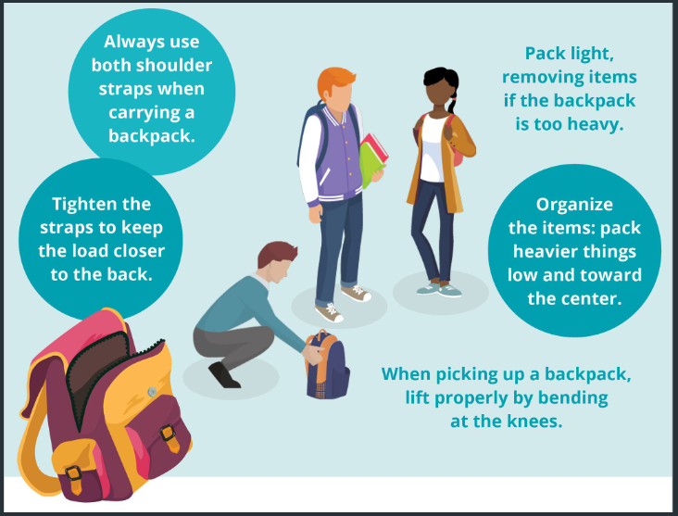
Disponível em: https://bit.ly/3ksPsJi. Acesso em: 29 abr. 2022. Adaptado para fins didáticos.

D Questão 04 –––––––––––––––––––––––––––◊
Qual é o assunto desse texto?
A) A venda de diferentes modelos de mochilas.
B) As maneiras corretas de usar mochilas.
C) O modo adequado de organizar mochilas.
D) Os objetos que devem ser levados nas mochilas.

D Questão 05 –––––––––––––––––––––––––––◊
Nesse texto, no trecho “Pack light, removing items if the backpack is too heavy.”, o termo em destaque indica
A) causa.
B) comparação.
C) condição.
D) tempo.

Leia o texto abaixo e responda as questões 06 e 07.

What’s It Gonna Be

Hey you what’s the deal
It’s popping up in here, wanna have a good time
Just try’na deal, when
I Couldn’t help to notice how you’ starin’ at me

Ooh baby you’re so fine
You deserve a time [...]
So boy why don’t ya, baby why won’t ya
Come and talk to me? [...]

BEYONCÉ. Disponível em: https://bit.ly/3kMxwJO. Acesso em: 5 maio 2022. Fragmento.
D Questão 06 –––––––––––––––––––––––––––◊
Nesse texto, no trecho “It’s popping up in here,...” (1ª estrofe), a expressão destacada foi utilizada para
A) demonstrar que alguém está fazendo sucesso.
B) indicar que alguém está frequentando algum lugar.
C) mostrar que o eu lírico está incomodado com alguém.
D) sugerir que o eu lírico está observando alguém.

D Questão 07 –––––––––––––––––––––––––––◊
Nesse texto, as expressões “gonna”, “wanna” e “ya” são típicos da linguagem
A) arcaica.
B) científica.
C) coloquial.
D) formal.

D Questão 08 –––––––––––––––––––––––––––◊
Leia o texto abaixo.

Disponível em: https://bit.ly/3LHDGqH. Acesso em: 3 maio 2022.

Nesse texto, a expressão “XO”, utilizada ao final de cada mensagem, tem o mesmo sentido de
A) abraços e beijos.
B) adeus e sorte.
C) amor e apoio.
D) artistas e fãs.

Leia o texto abaixo e responda as questões 09 e 10.

San Francisco

In June, Diane visited her friends who live in San Francisco, California. This was Diane’s first time in the city, and she enjoyed her opportunities to walk around and explore.
On the first day of her trip, Diane visited the Golden Gate Bridge. This red suspension bridge measures 1.7 miles in length. Diane and her friends did not walk across the bridge. However, they viewed it from the Golden Gate National Recreation Area, which offers hiking trails, picnicking areas, and presents spectacular views of the bridge and city. Diane and her friends made sure to take a group photograph here, featuring the bridge in the background. […]
Diane and her friends spent the final day of her visit in San Francisco’s downtown¹ area. Diane’s favorite part of her entire trip was taking a trolley to transport her up and down the hilly streets² of San Francisco.

*Vocabulário:
¹downtown: centro.
²hilly streets: ruas montanhosas.

Disponível em: https://lingua.com/pt/ingles/leitura/san-francisco/. Acesso em: 24 fev. 2022. Fragmento.

D Questão 09 –––––––––––––––––––––––––––◊
De acordo com esse texto, a parte preferida de Diane no passeio foi
A) andar de bonde.
B) conhecer o centro de San Francisco.
C) tirar fotografias na área de recreação.
D) ver a ponte Golden Gate.

D Questão 10 –––––––––––––––––––––––––––◊
Nesse texto, no trecho “… which offers hiking trails,…” (2° parágrafo), a palavra destacada retoma
A) San Francisco’s downtown area.
B) the Golden Gate Bridge.
C) the Golden Gate National Recreation Area.
D) the hilly streets of San Francisco.

Gabarito:
(01): A (02): C (03): A
(04): B (05): C (06): B
(07): C (08): A (09): A
(10): C

