SIMULADO DE INGLÊS
Escola:
Professor (a): | Data:____/_____/______
Estudante: | Turma:
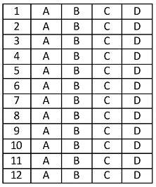

Leia o texto abaixo e responda as questões 01 e 02.

Britain’s New King
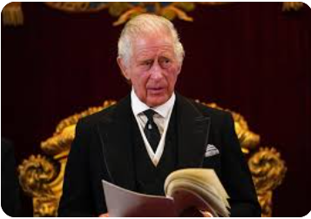
Disponível em: https://bityli.com/lesoG. Acesso em 11 dez 2022.

King Charles III was officially named Britain’s head of state on September 10. The ceremony was held at St. James’s Palace, in London, England. The tradition is centuries old. But this was the first time it was broadcast live¹ online and on TV.
In a speech² , Charles promised to follow his mother’s “inspiring example” as he took on his new role. “I am deeply aware of this great inheritance³ and of the duties⁴ and heavy responsibilities... which have now passed to me,” he said.
The ceremony ended when a royal official announced the news from a palace balcony. With trumpet players by his side, he led cheers of “Hip, hip, hooray!” for the new king.
King Charles’s coronation, or official crowning, is likely months away. It will be held at London’s Westminster Abbey.

*Vocabulário:
¹broadcast live: transmitido ao vivo.
²speech: discurso.
³inheritance: herança.
⁴duties: deveres.
FERNANDEZ, Cristina. Britain’s New King. In: Time for Kids. 2022. Disponível em: https://bityli.com/dUumI5 . Acesso em: 15 set. 2022.

D Questão 01 –––––––––––––––––––––––––––◊
O assunto desse texto é
A) a cerimônia ocorrida no palácio de St. James.
B) a participação de Charles III em programas de TV.
C) as responsabilidades reais de Charles III.
D) as tradições reais realizadas ao longo dos séculos.

D Questão 02 –––––––––––––––––––––––––––◊
Nesse texto, a linguagem utilizada no trecho “‘I am deeply aware of this great inheritance and of the duties and heavy responsibilities... which have now passed to me.’” (2º parágrafo) é tipicamente
A) coloquial.
B) formal.
C) literária.
D) regional.

D Questão 03 –––––––––––––––––––––––––––◊
Leia o texto abaixo.
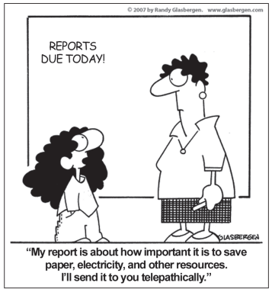
GLASBERGEN, Randy. In: Glasbergen Cartoon Service. 2007. Disponível em: https://bit.ly/3UAF0k6. Acesso em: 19 jul. 2022.

Nesse texto, no trecho “... how important it is to save paper,...”, o termo destacado quer dizer
A) guardar.
B) manter.
C) poupar.
D) salvar.
Leia o texto abaixo e responda as questões 04, 05 e 06.

Mirrors

Aren’t you somethin’ to admire?
Cause your shine is somethin’ like a mirror
And I can’t help but notice
You reflect in this heart of mine
If you ever feel alone and
The glare makes me hard to find
Just know that I’m always
Parallel on the other side […]

It’s like you’re my mirror
My mirror staring back at me
I couldn’t get any bigger
With anyone else beside me
And now it’s clear as this promise
That we’re making
Two reflections into one
Cause it’s like you’re my mirror
My mirror staring back at me
Staring back at me

Cause it doesn’t seem really as simple
And I can’t help but stare, cause
I see truth somewhere in your eyes
I can’t ever change without you
You reflect me, I love that about you
And if I could, I
Would look at us all the time [...]
TIMBERLAKE, Justin. Disponível em: https://www.vagalume.com.br/justin-timberlake/mirrors.html. Acesso em: 21 jul. 2022. Fragmento.

D Questão 04 –––––––––––––––––––––––––––◊
De acordo com esse texto, o eu lírico vê verdade
A) no brilho da amada.
B) no coração da amada.
C) nos olhos da amada.
D) nos reflexos da amada.

D Questão 05 –––––––––––––––––––––––––––◊
Nesse texto, no verso “I couldn’t get any bigger” (2ª estrofe), a terminação “-er” foi utilizada para indicar
A) comparação.
B) igualdade.
C) inferioridade.
D) superioridade.

D Questão 06 –––––––––––––––––––––––––––◊
Nesse texto, no verso “Cause your shine is somethin’ like a mirror” (1ª estrofe), a palavra em destaque indica
A) adição.
B) conclusão.
C) condição.
D) explicação.

Leia o texto abaixo e responda as questões 07 e 08.

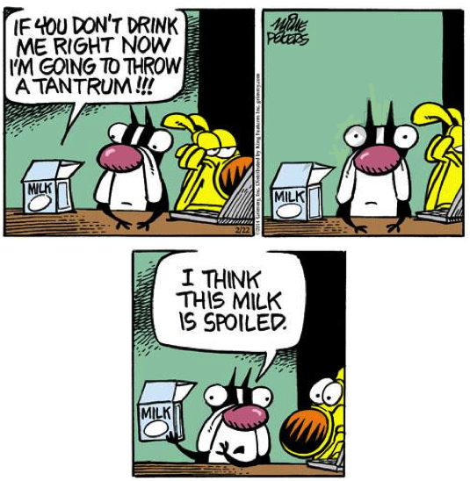
*Vocabulário:
¹tantrum: birra, ataque de raiva.
Disponível em: https://bityli.com/VRxPu. Acesso em: 12 set. 2022.

D Questão 07 –––––––––––––––––––––––––––◊
Nesse texto, a palavra “spoiled” tem o mesmo sentido de
A) desperdiçado.
B) estragado.
C) estressado.
D) mimado.

D Questão 08 –––––––––––––––––––––––––––◊
Nesse texto, no trecho “... I’m going to throw...”, a expressão destacada foi utilizada para indicar uma ação que
A) acontecerá.
B) é frequente.
C) está acontecendo.
D) já aconteceu.

Leia o texto abaixo e responda as questões 09 e 10.

20 best dog toys to entertain every type of dog in 2022
Choosing the right toys for your dog can provide comfort and keep them entertained — we compiled some highly rated options for any type of pup.

If you’re one of the nearly 70 million U.S. households¹ that owns a dog, you probably already know just how important it is to keep your pup² occupied and active throughout the day. In addition to food, treats and beds, dog toys³ are an essential that can keep their minds and bodies engaged, fight boredom⁴ when they’re home alone and provide comfort when they’re nervous.
However, it’s important to keep an eye on your dog when they’re testing out new toys, and determining the safest options for your furry friend⁵ can be the difference between a play session and a trip to the vet. To help you find the best toys for your dog, we spoke to professional dog trainers about the various safety considerations to keep in mind while shopping and highlighted the best toys worth considering based on their recommendations and guidance. […]
There are plenty of toys out there for all kinds of dogs, whether they’re young puppies or large, aggressive chewers⁶ . And dogs usually have their own preferences when it comes to what they like to play with. “Take your pup to a local store and let them pick out their toy — it’s so much fun to see what your dog prefers,” said Khara Schuetzner, a certified professional dog trainer and owner of training facility The Doggie Spot, which also sells dog toys in its store in Shawnee, Oklahoma.
Choosing the right toy for your dog can depend on a few factors, including your dog’s size and their activity level. […]

*Vocabulário:
¹U.S. households: famílias americanas.
²pup: cachorrinho.
³toys: brinquedos.
⁴boredom: tédio.
⁵furry friend: amigo peludo.
⁶chewers: mastigadores.

GODIO, Mili. 20 best dog toys to entertain every type of dog in 2022. In: nbc news. 2022. Disponível em: https://bityli.com/tjOgQ. Acesso em: 20 set. 2022. Fragmento.

D Questão 09 –––––––––––––––––––––––––––◊
A informação principal desse texto está no trecho:
A) “In addition to food, treats and beds, dog toys are an essential that can keep their minds and bodies engaged,…”. (1º parágrafo)
B) “To help you find the best toys for your dog, we spoke to professional dog trainers about the various safety considerations to keep in mind while shopping…”. (2º parágrafo)
C) “And dogs usually have their own preferences when it comes to what they like to play with.”. (3º parágrafo)
D) “Choosing the right toy for your dog can depend on a few factors, including your dog’s size and their activity level.”. (4º parágrafo)

D Questão 10 –––––––––––––––––––––––––––◊
Nesse texto, no trecho “... that can keep their minds and bodies engaged,…” (1º parágrafo), a palavra em destaque se refere a
A) beds.
B) dog toys.
C) food.
D) treats.

Gabarito:
(01): A (02): B (03): C
(04): C (05): A (06): D
(07): D (08): A (09): A
(10): B

