SIMULADO DE INGLÊS
Escola:
Professor (a): | Data:____/_____/______
Estudante: | Turma:
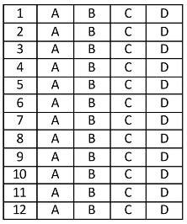

Leia o texto abaixo e responda as questões 01, 02 e 03.

Texto 1

Why I love reading and reviewing books

Reading develops our brains and gives us the ability to understand life in a much better fashion. Besides, there’s a lot of room for grammar and language development. When you read a lot, you learn new words all the time.
[...] I read two books simultaneously (one fiction and one nonfiction) every four weeks or so, which adds up to about 25 books per year.
As a rule, I always read at least a few pages every day. Often it is a lot more than that, and again at times, there’s a block. I squeeze reading in whenever I can – primarily during travelling, after waking up, in between classes and then of course throughout the weekend. [...]
MALLIK, Sukanya Basu. Why I love reading and reviewing books. In: Readers’ blog. 2019. Disponível em: https://bit.ly/3vXmE1a. Acesso em: 3 maio 2022. Fragmento.

Texto 2
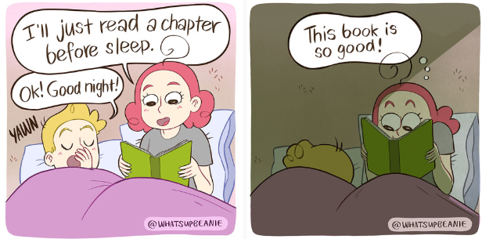
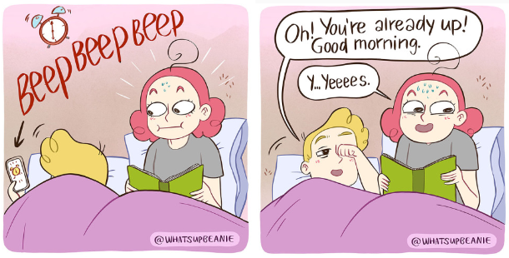
TYSOE, Alina. What’s up Beannie? 2022. Disponível em: https://bit.ly/3vBxbA4. Acesso em: 3 maio 2022. Adaptado para fins didáticos.

D Questão 01 –––––––––––––––––––––––––◊
Esses textos são parecidos, pois
A) abordam o amor pela leitura.
B) citam os benefícios da leitura.
C) indicam uma boa noite de sono.
D) mostram os hábitos de um casal.

D Questão 02 –––––––––––––––––––––––––◊
No Texto 2, no trecho “I’ll just read a chapter before sleep.” (1º quadrinho), a expressão destacada foi utilizada para
A) apresentar uma probabilidade.
B) indicar uma ordem.
C) informar uma ação futura.
D) oferecer uma sugestão.

D Questão 03 –––––––––––––––––––––––––◊
No Texto 1, no trecho “... there’s a lot of room for grammar and language development.” (1º parágrafo), a palavra destacada significa
A) espaço.
B) local.
C) quarto.
D) sala.

Leia o texto abaixo e responda as questões 04, 05 e 06.
Seeds on the Move

Most plants start as a seed. Plants spread their seeds. This helps them find new places to grow. Here are ways seeds travel.
Blowing in the Wind
Some seeds are very light. Some are shaped like wings¹. Seeds like this can travel through the air.
Carried by Animals
Animals eat fruit and drop seeds elsewhere. Animals can carry seeds away on their fur² or feathers³.
Floating on Water
A coconut is a type of seed. This one has fallen in water. It travels until it reaches land. Then it will grow roots⁴.
Bursting Open
Some fruits and pods⁵ can explode! This is a squirting cucumber. The fruit sprays seeds and water when it is touched.
Did you know?
People can spread seeds too. Wear old socks6 over your shoes. Wet the socks. Walk in nature. Then plant the socks in soil. See if anything grows!

*Vocabulário:
¹wings: asas.
²fur: pelo.
³feather: pena.
⁴roots: raízes.
⁵pods: vagens.
⁶socks: meias.

TIME FOR KIDS. Seeds on the Move. 2022. Disponível em: https://bityli.com/SOG99. Acesso em: 3 maio 2022.

D Questão 04 –––––––––––––––––––––––––––◊
De acordo com esse texto, um “coconut” é um tipo de
A) animal.
B) fruit.
C) plant.
D) seed.

D Questão 05 –––––––––––––––––––––––––––◊
O objetivo desse texto é
A) apresentar uma opinião.
B) dar uma informação.
C) divulgar uma pesquisa.
D) ensinar uma tarefa.
D Questão 06 –––––––––––––––––––––––––––◊
Nesse texto, no trecho “The fruit sprays seeds and water when it is touched.”, a palavra destacada indica
A) adição.
B) conclusão.
C) condição.
D) oposição.

D Questão 07 –––––––––––––––––––––––––––◊
Leia o texto abaixo.

Playing Catch

Kate and her brother Jake like to play catch. They play with softballs, footballs and tennis balls. They toss the balls back and forth in the yard all the time.
Sometimes they go to the park to have more space for throwing the balls farther. When it is raining out, they play catch in the basement. They use a tennis ball because it bounces off of the basement walls.
Jake is going to soccer camp for a week this summer. Kate is going to soccer camp for a week this summer. Kate is sad because she won’t have anyone to play catch with while he is gone.
The week before Jake leaves, they go to the park together. There is a girl tossing a ball in the air by herself. Kate and Jake invite her to play with them. Her name is Brooke. Kate is happy now that she has a new friend to play catch with while her brother is at camp.
Disponível em: https://www.liveworksheets.com/zu1202967id. Acesso em: 6 maio 2022.

Nesse texto, no trecho “There is a girl tossing a ball in the air by herself.” (4º parágrafo), a expressão destacada foi utilizada para
A) demonstrar que a garota queria brincar com a bola.
B) expressar que a garota gostava de ir ao parque.
C) indicar que a garota estava brincando sozinha.
D) mostrar que a garota achava a brincadeira difícil.

Leia o texto abaixo e responda as questões 08, 09 e 10.

Vietnam opens glass bridge¹ with gobsmacking views² across gorge³
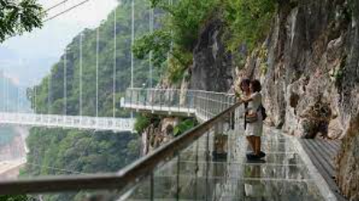
Disponível em https://bityli.com/mtO2u. Acesso em dez 2022.

Whatever you do, don’t look down! Vietnam has a new attraction for tourists who have a head for heights, with the opening on Friday of a glass-bottomed bridge suspended 150m above a lush jungle.
The Bach Long pedestrian bridge – whose name translates to “white dragon” – in northwest Son La province snakes around dizzying cliff faces before spanning a dramatic valley between two peaks, hitting a total length of 632m.
The floor of the bridge is made of tempered glass from France, making it strong enough to support up to 450 people at a time, while giving them a spectacular view of the greenery in the gorge far below.
“When standing on the bridge, travellers will be able to admire the beauty of nature,” said bridge operator spokesperson4 Hoang Manh Duy.
The company said it was the world’s longest glass-bottomed bridge, surpassing a 526m structure in Guangdong, China.
Officials from Guinness World Records are expected to verify the claim next month. [...]
Bach Long is Vietnam’s third glass bridge.
“I hope the bridge will lure more domestic and international tourists to our area,” local resident Bui Van Thach said after walking across it.

*Vocabulário:
¹glass bridge: ponte de vidro.
²gobsmacking views: vistas chocantes.
³gorge: desfiladeiro.
⁴spokeperson: porta-voz.

AFP. Vietnam opens glass bridge with gobsmacking views across gorge. 2022. Disponível em: https://bit.ly/3P2TUwv. Acesso em: 6 maio 2022. Fragmento.

D Questão 08 –––––––––––––––––––––––––––◊
A informação principal desse texto está no trecho:
A) “Vietnam has a new attraction for tourists who have a head for heights, with the opening on Friday of a glass-bottomed bridge suspended 150m above a lush jungle.”. (1º parágrafo)
B) “The floor of the bridge is made of tempered glass from France, making it strong enough to support up to 450 people at a time,...”. (3º parágrafo)
C) “‘When standing on the bridge, travellers will be able to admire the beauty of nature,’ said bridge operator spokesperson Hoang Manh Duy.”. (4º parágrafo)
D) “‘I hope the bridge will lure more domestic and international tourists to our area,’ local resident Bui Van Thach said after walking across it.”. (8º parágrafo)

D Questão 09 –––––––––––––––––––––––––––◊
Nesse texto, no trecho “... tourists who have a head for heights,...” (1º parágrafo), a palavra destacada tem o mesmo sentido de
A) cair.
B) gostar.
C) guiar.
D) tropeçar.

D Questão 10 –––––––––––––––––––––––––––◊
Nesse texto, no trecho “... whose name translates to ‘white dragon’...” (2º parágrafo), a palavra destacada faz referência a
A) France.
B) Son La province.
C) The Bach Long pedestrian bridge.
D) Vietnam.

Gabarito:
(01): A (02): C (03): A
(04): D (05): B (06): A
(07): C (08): A (09): B
(10): C

