SIMULADO DE INGLÊS
Escola:
Professor (a): | Data:____/_____/______
Estudante: | Turma:
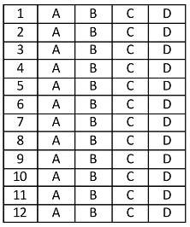

Leia o texto abaixo e responda as questões 01 e 02.

A Koala in Russia

Once upon a time, there were animals in the Russian forest, and then in winter a koala suddenly came to the forest from Australia!
The koala said something but nobody understood what it was talking about. The wolf called Nick remembered that only bears could understand it [...]! But all bears sleep in winter… What could Nick do?
He thought: ‘I know! I need to wake up my friend, a bear Misha!’
So the wolf tried to wake him up, but the bear didn’t hear nor moved an inch because Misha had a deep sleep. Nick called and gathered all the forest animals, and they woke the bear. Finally, the bear translated the speech of koala. His name was Oliver and it turned out that the koala was travelling and exploring animals of different countries. Bear Oliver asked the information about squirrels, hares1 , foxes and elks2 . [...] Animals of all the forest really liked the stories and wondered how these animals look like in real life as they never saw something like that before in the forest. All in all, the wolf Nick became interested in travelling and decided to learn foreign languages in order to travel to different countries too. Take an example from our wolf! [...]

*Vocabulário:
¹hares: lebres. ²elks: alces.
SAFONOVA, Ulyana. A Koala in Russia. In: Fairytalez. Disponível em: https://bityli.com/3wLqc /. Acesso em: 2 maio 2021. Fragmento.

D Questão 01 –––––––––––––––––––––––––––◊
De acordo com esse texto, o animal chamado Nick é um
A) coala.
B) esquilo.
C) lobo.
D) urso.

D Questão 02 –––––––––––––––––––––––––––◊
Nesse texto, no trecho “… the bear didn’t hear nor moved an inch...” (4º parágrafo), a expressão destacada foi usada para
A) apontar que os ursos migram entre vários países.
B) demonstrar que o urso não se moveu.
C) expressar que os animais não mantêm distância do urso.
D) indicar que o urso demora a caminhar.

D Questão 03 –––––––––––––––––––––––––◊
Leia o texto abaixo.
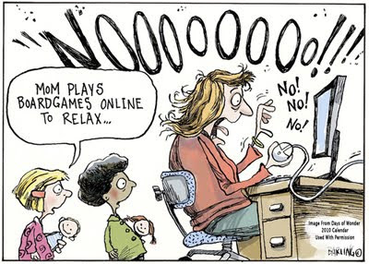
Disponível em: https://bityli.com/sFsG5. Acesso em: 1 jul. 2022.

Infere-se desse texto que
A) as crianças esperam sua vez de jogar.
B) as crianças estão prontas para dormir.
C) os jogos deixam a mulher estressada.
D) os jogos são muito difíceis de se jogar.

D Questão 04 –––––––––––––––––––––––––––◊

Leia o texto abaixo.
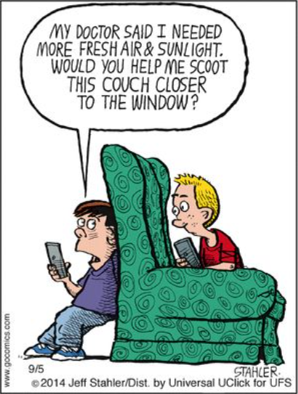
Disponível em: https://bit.ly/3hv2K6V. Acesso em: 24 fev. 2022.

Entende-se desse texto que o menino
A) convidou seu amigo para brincar de esconde-esconde.
B) descobriu que o sinal da internet é melhor atrás do sofá.
C) deseja tomar sol e ar fresco sem sair de casa.
D) desequilibrou-se e caiu do sofá enquanto brincava.

Leia o texto abaixo e responda as questões 05, 06 e 07.
Scientists Make Meat

A laboratory in the Netherlands uses cow¹ muscle and fat to grow meat, revolutionising what we eat.
Currently, a little piece of meat costs around $12,500 to make, but professor Mark Post said that the laboratory has an investor from the meat industry, and he envisions² that it will take about three years to get the first hamburger on the market.
It will be still rather expensive and in small production, so it will target only specialty restaurants at a price of 12–14 dollars for a hamburger, but the price will inevitably come down in the years after that. The production will be more resource efficient and it will hit the supermarket seven years from now, according to the professor’s guess.
A butcher said that people are very sceptical and nervous about manufactured products as it is, and scientists agree that public acceptance is key to the success of this product.
*Vocabulário:
¹cow: vaca.
²envisions: prevê.
Disponível em: https://bityli.com/oxbzz. Acesso em: 5 jul. 2022.

D Questão 05 –––––––––––––––––––––––––––◊
A informação principal desse texto está no trecho:
A) “A laboratory in the Netherlands uses cow muscle and fat to grow meat, revolutionising what we eat.”. (1° parágrafo)
B) “... that it will take about three years to get the first hamburger on the market.”. (2° parágrafo)
C) “It will be still rather expensive and in small production, so it will target only specialty restaurants at a price of 12–14 dollars for a hamburger,...”. (3° parágrafo)
D) “... scientists agree that public acceptance is key to the success of this product.”. (4° parágrafo)

D Questão 06 –––––––––––––––––––––––––––◊
Nesse texto, predomina a linguagem
A) coloquial.
B) formal.
C) regional.
D) técnica.

D Questão 07 –––––––––––––––––––––––––––◊
Nesse texto, no trecho “... but professor Mark Post said...” (2º parágrafo), o termo em destaque foi utilizado para
A) apontar finalidade.
B) indicar explicação.
C) marcar adição.
D) mostrar oposição.

Leia o texto abaixo e responda as questões 08 e 09.

I couldn’t believe my eyes

‘Guess what I saw at 7 o’clock this morning when I was walking to school on Hassan Street?’
‘I don’t know. Tell me.’
‘I was halfway along the street when I saw a huge parade coming towards me. The Russian circus was coming to town.
‘First there were three white elephants, with two children riding on each of them.
‘Then there were four tall giraffes, and they each had one woman rider.
‘Then came the clowns. Two in a funny car and three were running behind it.
‘Last of all, there were two big, clear balls. Each with a clown inside and one balancing on top.
‘So, Karim, how many people were there on Hassan Street going to school at 7 o’clock today?’
‘Mmm. Hold on! I need time to think. You saw a lot of people.’
Disponível em: https://bit.ly/3I26SHG. Acesso em: 30 jun. 2022.

D Questão 08 –––––––––––––––––––––––––◊
De acordo com esse texto, quantos elefantes brancos havia no circo?
A) Dois.
B) Sete.
C) Três.
D) Quatro.

D Questão 09 –––––––––––––––––––––––––◊
Nesse texto, no trecho “‘So, Karim,...’” (8º parágrafo), a palavra em destaque indica
A) conclusão.
B) condição.
C) finalidade.
D) oposição.

D Questão 10 –––––––––––––––––––––––––––◊
Leia o texto abaixo.
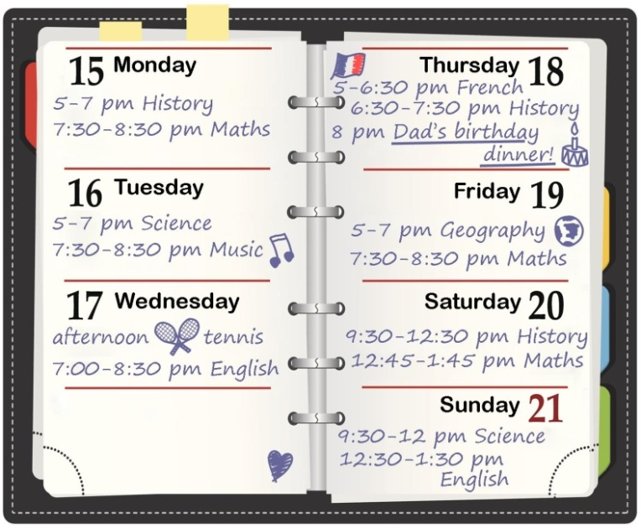
Disponível em: https://bit.ly/3ImVc1G. Acesso em: 24 fev. 2022.

De acordo com esse texto, a aula de Geografia acontece em qual dia da semana?
A) Friday.
B) Thursday.
C) Tuesday.
D) Wednesday.

Gabarito:
(01): C (02): B (03): C
(04): C (05): A (06): B
(07): D (08): C (09): A
(10): A

