SIMULADO DE INGLÊS
Escola:
Professor (a): | Data:____/_____/______
Estudante: | Turma:
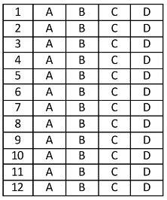

Leia o texto abaixo eas questões 01, 02 e 03.

Lost and Found

Donna and her husband John go to the beach every Saturday in the summer. Today is no exception. Donna packs a picnic lunch. She packs the beach umbrella and sun lotion.
She cannot find their beach towels. Donna always loses things. The towels are not in the laundry basket or dryer. They are not in the closet, either. She finally looks in her beach bag. She sees the towels folded in the bottom. Of course, the beach towels are exactly where they should be.
Donna puts on her swimsuit and floppy sun hat. She is almost ready. She just needs her sunglasses. She thinks they are on the table by the door. Or maybe they are in the bathroom. They could also be in her purse. Donna sighs.
John puts the picnic basket, umbrella, and beach bag in the car. He checks his fishing poles and equipment. He places them in the car beside the picnic basket. Daisy, their dog, jumps in the backseat. She loves the beach! John is ready to leave. Where is Donna? She knows he likes to arrive at the beach before the crowds.
John groans and shakes his head. Donna is always late!
Donna searches for her sunglasses. She cannot find them, and she knows John is waiting. He hates when she is late! She grabs her purse and locks the door.
“You are late,” John says as Donna gets in the car. Donna tells John that she could not find her sunglasses.
John looks at her and laughs! He flips down the sun visor so Donna can see herself in the mirror. Donna looks in the mirror and laughs too. Her sunglasses are on top of her head. They were there the whole time!
“It is always in the last place that you look,” Donna giggles!
Disponível em: https://bit.ly/3sh6qiJ. Acesso em: 24 fev. 2022.

D Questão 01 –––––––––––––––––––––––––––◊
De acordo com esse texto, onde estava a toalha de Donna?
A) In the bathroom.
B) In the beach bag.
C) In the closet.
D) In the laundry basket.

D Questão 02 –––––––––––––––––––––––––––◊
Qual é a palavra em Língua Inglesa que está relacionada a esse texto?
A) Airplane.
B) Bicycle.
C) Brother.
D) Weekend.

D Questão 03 –––––––––––––––––––––––––◊
Nesse texto, no trecho “Or maybe they are in the bathroom.” (3º parágrafo), o termo destacado estabelece uma relação de
A) adição.
B) alternância.
C) conclusão.
D) oposição.

Leia o texto abaixo e responda as questões 04 e 05.
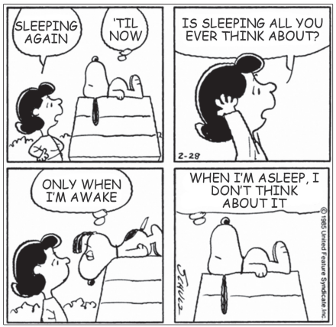
Disponível em: https://bit.ly/3hCeMeC. Acesso em: 3 mar. 2022.

D Questão 04 –––––––––––––––––––––––––––◊
Entende-se desse texto que
A) a menina se irritou com o cachorro.
B) a menina quis acordar o cachorro.
C) o cachorro gosta muito de dormir.
D) o cachorro reflete enquanto dorme.

D Questão 05 –––––––––––––––––––––––––––◊
No primeiro quadrinho desse texto, a linguagem utilizada na expressão “´til now” é
A) científica.
B) informal.
C) padrão.
D) técnica.

Leia o texto abaixo e responda as questões 06 e 07.

Who Is Bruno Mars?

Singer-songwriter Bruno Mars began to find success in the early 2000s by writing songs for popular artists, including K’Naan’s “Wavin’ Flag”. After several years as one of pop music’s premier songwriters, Mars broke out as a singer in his own right with the 2010 hit “Nothin’ on You.” Other popular songs by Mars include “Just the Way You Are” (2010), “Locked Out of Heaven” (2012) and the Grammy-winning tracks “Uptown Funk” (2015) and “That’s What I Like” (2017).
Born Peter Gene Hernandez on October 8, 1985, in Honolulu, Hawaii, singer-songwriter Bruno Mars grew up in a very musical family. His father, Pete, was a Latin percussionist from Brooklyn, and his mother, Bernadette (“Bernie”), was a singer. Mars received his nickname, “Bruno”, while he was still a baby. “The name Bruno came from baby times,” older sister Jamie explained. “Bruno was always so confident, independent, really strong-willed and kind of a brute — hence the name Bruno — and it kind of just stuck.” […]
Disponível em: https://www.biography.com/musician/bruno-mars. Acesso em: 25 fev. 2022. Fragmento.

D Questão 06 –––––––––––––––––––––––––––◊
Qual é o assunto desse texto?
A) A vida de Bruno Mars.
B) As músicas populares.
C) O nascimento de Bruno Mars.
D) Os apelidos de infância.

D Questão 07 –––––––––––––––––––––––––––◊
Nesse texto, no trecho “Mars received his nickname,…” (2° parágrafo), a palavra em destaque significa
A) apelido.
B) elogio.
C) título.
D) vocação.

D Questão 08 –––––––––––––––––––––––––––◊
Leia o texto abaixo.

Disponível em: https://bit.ly/3yAGjXJ. Acesso em: 6 maio 2022.

A finalidade desse texto é
A) dar uma opinião.
B) ensinar uma tarefa.
C) fazer um anúncio.
D) relatar um fato.
D Questão 09 –––––––––––––––––––––––––––◊
Leia o texto abaixo.
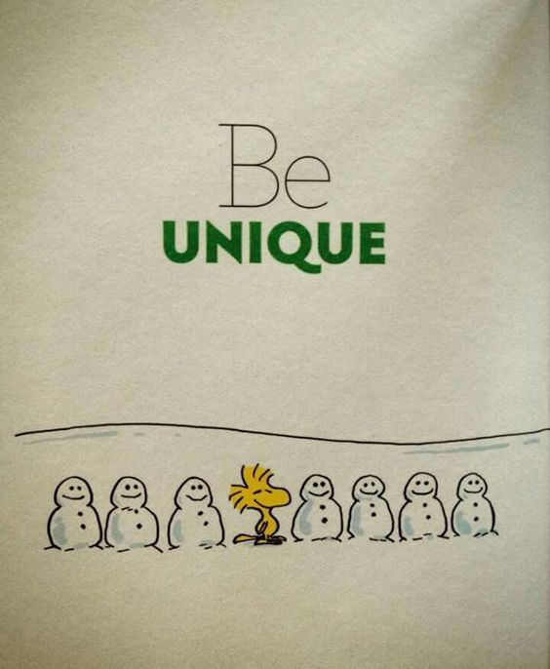
Disponível em: https://br.pinterest.com/pin/281543717750095/. Acesso em: 22 fev. 2022.

Uma palavra em Língua Inglesa relacionada a esse texto é
A) ice.
B) river.
C) toy.
D) tree.

D Questão 10 –––––––––––––––––––––––––––◊
Leia o texto abaixo.
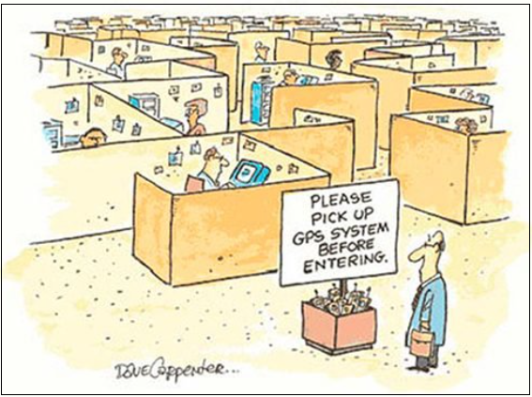
CARPENTER, Dave. Disponível em: https://www.rd.com/list/daily-life-cartoons/. Acesso em: 2 maio 2022.

Entende-se desse texto que
A) o homem está com medo de entrar em seu local de trabalho.
B) o homem precisa de ajuda para encontrar seu local de trabalho.
C) os colegas de trabalho do homem ainda não o conhecem.
D) os colegas de trabalho do homem não precisam de ajuda em suas tarefas.

Gabarito:
(01): B (02): D (03): B
(04): C (05): B (06): A
(07): A (08): C (09): A
(10): B

