SIMULADO DE INGLÊS
Escola:
Professor (a): | Data:____/_____/______
Estudante: | Turma:
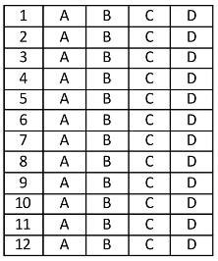

Leia o texto abaixo e responda as questões 01, 02 e 03.
July Is National Ice Cream Month!

July is National Ice Cream Month. This means it is your civic duty to consume a scoop or two of the delicious treat daily. [...]
The decree urges Americans to mark the month, or at least July 17 — designated National Ice Cream Day — with “appropriate ceremonies and activities.” [...]
The first records of milk-based ice cream, made using heated fermented milk, flour, and camphor, come from China’s Tang dynasty (618 – 907 AD). But the Arabs are credited with inventing the modern-day recipe, using milk and sugar as the primary ingredients, in the 9th century. By the 10th century, the delicious treat, made using milk, cream, flavored rosewater, dried fruits, and nuts, was widely available in Baghdad, Damascus, and Cairo. [...]
DOLASIA, Kavi. July Is National Ice Cream Month! In: Dogo news. 2022. Disponível em: https://bityli.com/hNPPj. Acesso em: 6 jul. 2022. Fragmento.

D Questão 01 –––––––––––––––––––––––––––◊
Nesse texto, no trecho “... a scoop or two of the delicious treat daily.” (1º parágrafo), a palavra destacada significa
A) guloseima.
B) medicamento.
C) presente.
D) surpresa.

D Questão 02 –––––––––––––––––––––––––––◊
A informação principal desse texto está no trecho:
A) “July is National Ice Cream Month.”. (1º parágrafo)
B) “… with ‘appropriate ceremonies and activities.’” (2º parágrafo)
C) “The first records of milk-based ice cream, [...] come from China’s Tang dynasty...”. (3º parágrafo)
D) “... the delicious treat, [...] was widely available in Baghdad,...”. (3º parágrafo)

D Questão 03 –––––––––––––––––––––––––––◊
Nesse texto, no trecho “… flavored rosewater, dried fruits, and nuts,...” (3º parágrafo), a palavra destacada foi usada para
A) indicar explicação.
B) marcar adição.
C) revelar condição.
D) sugerir comparação.

D Questão 04 –––––––––––––––––––––––––––◊
Leia o texto abaixo.

Disponível em: https://bityli.com/B3cyD. Acesso em: 27 set. 2022.

Para convencer o leitor a adotar um animal, esse texto
A) apresenta maneiras diferentes de adoção.
B) coloca a expressão do cachorro em destaque.
C) evidencia a felicidade dos animais adotados.
D) ressalta as necessidades dos animais.
Leia o texto abaixo e responda as questões 05 e 06.

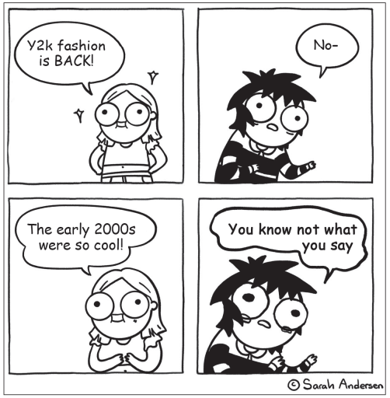
ANDERSEN, Sarah. Disponível em: https://sarahcandersen.com/page/12.

D Questão 05 –––––––––––––––––––––––––––◊
Nesse texto, a expressão “y2k” é uma abreviação para
A) yeah 2000.
B) years 2000.
C) you 2000.
D) young 2000.

D Questão 06 –––––––––––––––––––––––––––◊
A linguagem predominante nesse texto é
A) arcaica.
B) científica.
C) coloquial.
D) formal.

Leia o texto abaixo e responda as questões 07 e 08.

Should Summer Reading Be Mandatory?

Reading is fun! But should it be required? Many kids are assigned books to read over the summer. Some people say summer reading keeps kid’s minds sharp. Others say kids need a break. Here, TIME for Kids readers weigh in¹.
Yes
You’re on break, but that doesn’t mean you shouldn’t learn. Books can teach you anything and everything. You can learn new words or get inspired to create your own book! — Alexandra Kotsinis, 10, Westfield, New Jersey [...]
Yes, summer reading should be mandatory. It’s something fun that can replace screen time. — Kauther Haque, 10, Milton, Ontario, Canada.
No
[...] If summer reading is not mandatory, more kids will spend their time playing outside, which is a very healthy lifestyle to develop. — Aahil Bhagyaraj, 10, Chattanooga, Tennessee [...]
Summertime is a time for kids to relax, go outside, and enjoy just being a kid. — Pallavi Shah, 11, Scotch Plains, New Jersey.
Kids have activities planned for the summer, such as sleepaway camp and day camp, so they won’t have time for extra reading. — Naftali Bochner, 10, Bronx, New York
*Vocabulário:
¹weigh in: avaliam.

Disponível em: https://bityli.com/Doewr. Acesso em: 13 jul. 2022. Adaptado pra fins didáticos. Fragmento.

D Questão 07 –––––––––––––––––––––––––––◊
O objetivo desse texto é
A) divulgar pesquisas.
B) mostrar opiniões.
C) narrar histórias.
D) relatar experiências.

D Questão 08 –––––––––––––––––––––––––––◊
De acordo com esse texto, Kauther Haque acredita que
A) a leitura nas férias deveria ser obrigatória.
B) as crianças deveriam passar mais tempo brincando ao ar livre.
C) o verão é um período em que as crianças deveriam relaxar.
D) os livros podem ensinar qualquer coisa.

Leia o texto abaixo e responda as questões 09 e 10.

Family passes down $100 wedding dress for 72 years
So far, eight brides spanning three generations have worn¹ the special dress.
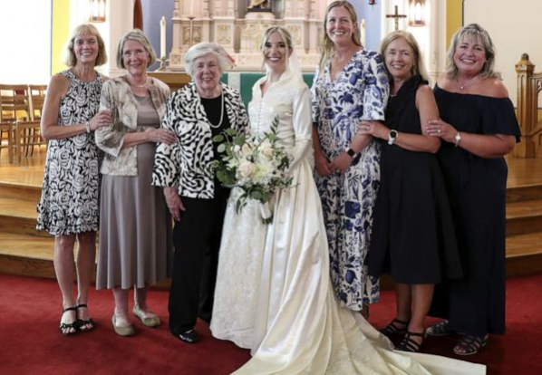
For more than seven decades, one family has upheld² a special tradition of passing down the same wedding dress. Now, they’re continuing the custom by preserving it for a new generation of relatives.
Overall³, eight brides have worn the same wedding dress. Adele Larson first wore the classic satin gown⁴ at her wedding to Roy Stoneberg on Sept. 16, 1950. The traditional dress features a mandarin collar, a lace panel in the front and back, and lots of small, fabric-covered buttons. She purchased⁵ it at Marshall Field’s department store in downtown Chicago, now home to Macy’s State Street, according to her niece, Julie Frank Mackey. “She bought it for $100.75, which, in this day and age, is kind of wild,” Mackey, 42, told [...]. “When you see it up close, the fabric, the satin and the lace⁶ are just really, really gorgeous and timeless⁷.” [...]

*Vocabulário:
¹have worn: usaram.
²has upheld: manteve.
³overall: no total.
⁴satin gown: vestido acetinado.
⁵purchased: comprou.
⁶lace: renda.
⁷timeless: atemporais.

YU, Yi-Jin. Family passes down $100 wedding dress for 72 years. In: abc News. 2022. Disponível em: https://abcn.ws/3UKatQU. Acesso em: 20 set. 2022. Fragmento.

D Questão 09 –––––––––––––––––––––––––––◊
A informação principal desse texto está no trecho:
A) “For more than seven decades, one family has upheld a special tradition of passing down the same wedding dress.”. (1º parágrafo)
B) “Adele Larson first wore the classic satin gown at her wedding to Roy Stoneberg on Sept. 16, 1950.”. (3º parágrafo)
C) “The traditional dress features a mandarin collar, a lace panel in the front and back, and lots of small, fabric-covered buttons.”. (3º parágrafo)
D) “She purchased it at Marshall Field’s department store in downtown Chicago, now home to Macy’s State Street,…”. (3º parágrafo)

D Questão 10 –––––––––––––––––––––––––––◊
Nesse texto, um trecho que mostra uma opinião é:
A) “For more than seven decades,...”. (1º parágrafo)
B) “... according to her niece, Julie Frank Mackey.”. (3º parágrafo)
C) “‘She bought it for $100.75,...’”. (4º parágrafo)
D) “‘... the satin and the lace are just really, really gorgeous...’”. (4º parágrafo)

Gabarito:
(01): A (02): A (03): B
(04): B (05): B (06): C
(07): B (08): A (09): A
(10): D

