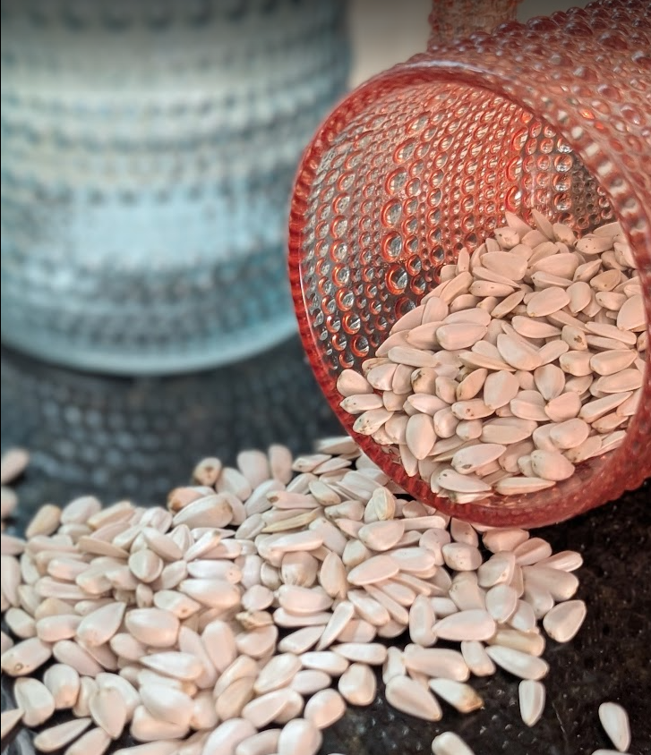
Planting Instructions
Carefully remove the pod from the bag and place it in a bowl adding about 1/4–1/2 cup of water.
The pod will expand and keep the seed moist. If the seed comes loose, tuck it back into the center of the pod.
Plant the expanded seed pod in an area that has well-drained soil.
Plant it about ½ inch deep. Just enough soil to lightly cover the top of the seed pod.
If there is no rain, water again in 3–4 days. Seedlings usually sprout in 7–10 days.
Protect young plants from curious creatures, and support stalk as it grows.
*If you have more than 1 seed pod, plant them about 2 feet apart-so every sunflower can rise in its own light.

