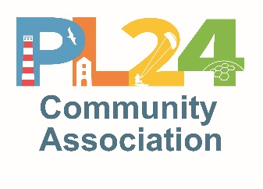
Resilience and capacity statement (Risk Management)

PL24 Community Association is a volunteer group – we have no paid employees.

Consequently, we need to be mindful of our volunteering capacity and the need to build in resilience.

Action undertaken to ensure our resilience includes;
- ensuring that all PL2CA email addresses can be accessed by a minimum of 2 officers, so information is readily retrievable;
- having a minimum of 3 bank signatories;
- sharing information on an ongoing basis, so that all organisational/administrative roles can be covered another volunteer, if necessary. For example, at least one Lead and one deputy is nominated for every activity/event, so it can go ahead, should the Lead be unavailable at the last moment.

Proposals for any new venture or undertaking should take the above principles into consideration.

March 2021 (Working Group Meeting 29.03.21.)

as reported in the Committee Minutes of 26.04.21.

