EMBARGOED UNTIL JANUARY 7, 2026 – 6:00 AM EST
Dateline: Jersey City, NJ — January 7, 2026 — 6:00 AM Eastern
Solara AirCar-2 Unveils the Sky Economy
An integrated dual-mode (drive + fly) personal mobility platform and premium unmanned ShiptoSky™ cargo service—designed to operate on 100% renewable energy
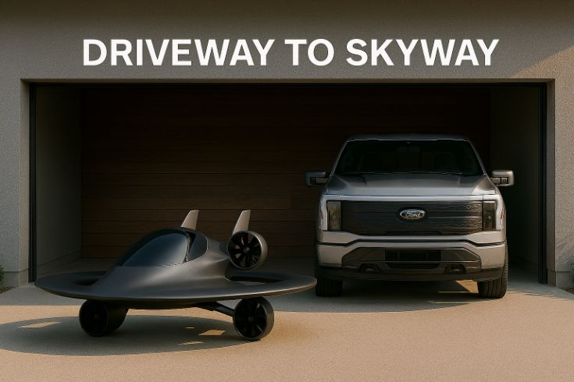
Figure 1. “Driveway to Skyway”—Solara AirCar-2 driveway-ready visualization (prototype).
JERSEY CITY, NJ — December 23, 2025 —
Solara AirCar™, an initiative of The Solara Collective, today unveiled a global media campaign for the Sky Economy—a new mobility and logistics layer connecting driveways to trade lanes with a 100% electric vehicle that drives and flies, and a premium, unmanned ShiptoSky™ container-lift service from cargo ship to end receiver.
“Solara AirCar isn’t just a vehicle—it’s an economic inflection point,” said Lawrence K. Woods, Founding Executive Chairman & Project Architect. “We’re bridging personal freedom and global commerce—fully electric, fully renewable, and inevitable.”
Why now (independent market signals):
- Air cargo tailwinds: Global demand hit a record in 2024 (+11.3% YoY) with yields still ~39% above 2019.
- Port throughput resilience: 183.2M TEU processed in 2024 (+6% YoY), underscoring the need for faster discharge lanes.
- Urban Air Mobility scaling: Market forecasts point to $4.6B (2024) → $23.5B (2030) → $41.5B (2035).
- Smart ports investing: Digital/low-carbon upgrades expected to expand from $4.49B (2025) to $11.06B (2030).
Two complementary products:
1) Solara AirCar™ (Personal) — “Driveway to Skyway.” A two-seat ground/air VTOL, 100% electric and designed for safe, quiet, clean neighborhood operations (program milestones forthcoming).
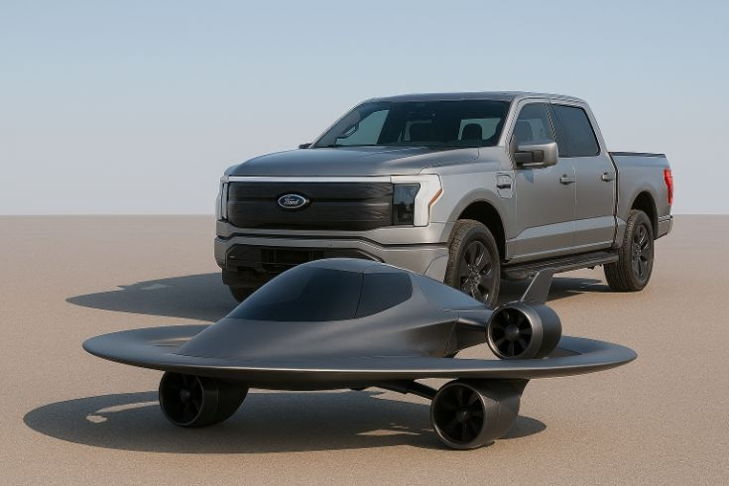
Figure 2. Solara AirCar-2 visualization shown alongside a production pickup for illustrative scale—no third‑party affiliation implied.
2) ShiptoSky™ (Industrial) — “From Port to Person, in Hours.” An unmanned aerial container-lift + trunk service moving standardized modules directly from ships/terminals to inland receivers—compressing days to hours and bypassing multi-stop road bottlenecks, aligned with smart-port automation (IoT/AI/AGVs).
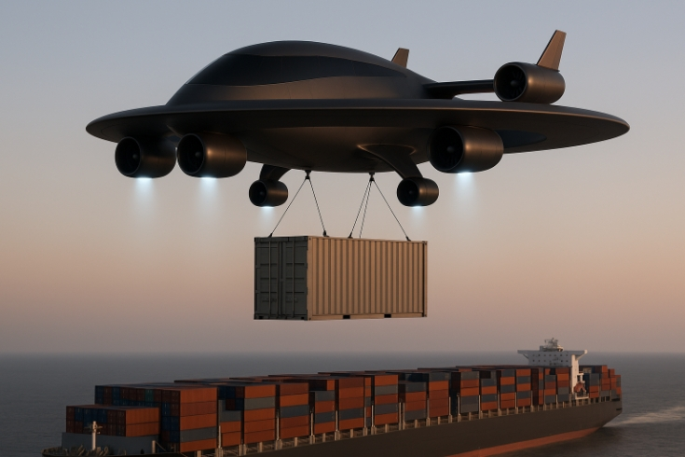
Figure 3. ShiptoSky™ heavy-lift VTOL concept performing standardized container-lift over a cargo vessel—operations subject to regulatory approvals.
Global automaker impact (condensed):
- Toyota × Joby: Plans to double U.S. eVTOL manufacturing; strategic manufacturing alliance.
- Stellantis × Archer: ~400,000 sq ft Covington, GA facility ramping; progressing to exclusive contract manufacturing; scale goal up to 650/year by 2030.
- Hyundai (Supernal): Tech-demonstrator flight testing and ecosystem partnerships toward 2028 commercialization.
- Honda: FAA exemption for subscale eVTOL; full-scale build by end-2025 and first flight targeted March 2026 (hybrid-electric architecture).
- Volkswagen Group: Gen.Urban autonomous testing in Wolfsburg focused on UX/digital interiors.
Pilot corridors (media exclusives available):
- United States: LA/Long Beach ↔ Inland Empire (electronics, pharma, peak e-commerce).
- Europe: Rotterdam ↔ Ruhrgebiet (automotive/chemicals; smart-terminal leadership).
- Africa: Lagos ↔ Abuja (rapid urbanization; congested road networks).
- Asia-Pacific: Singapore ↔ Jakarta (regional e-commerce; port digitization).
Illustrative adoption & revenue (forward-looking):
- Consumer (AirCar): Premium lease + service plans in select metros (Years 1–2); $250–$500M cumulative potential across two regions (Years 3–5), subject to certification and vertiport access.
- Industrial (ShiptoSky™): $25–$60M pilot-lane revenue (Year 1); $400–$800M cumulative potential across 6–10 corridors (Years 2–5), tied to container volumes and air-cargo yields.
Technology & sustainability:
First-to-market claim: “100% electric ground/air VTOL powered entirely by renewable energy” — patents pending. ESG impact: Electrified aerial legs cut multi-stop road emissions and lead times; fewer handoffs reduce buffer inventory and waste; smart-port integrations enable real-time transparency.
Media & investor access:
- First Look: Driveway-ready AirCar prototype photography/animations.
- Deep Dive: Technical brief on renewable-energy integration and ShiptoSky™ operations.
- Executive Interview: Lawrence K. Woods on Sky Economy timelines.
- Pilot Corridors: Onsite filming with port/city partners (under NDA).
Media Inquiries: press@thesolaracollective.com • +1 201 380 6565
Investor Relations: ir@thesolaracollective.com
About Solara AirCar™ / The Solara Collective
Solara AirCar™ designs personal VTOL vehicles and autonomous aerial logistics systems powered by 100% renewable energy, delivering freedom for people and speed for global trade—from driveways to terminals, across the Sky Economy.
Legal notice: Visualizations are prototype concepts for media purposes; specifications subject to change. Third‑party marks and products shown are the property of their respective owners; no endorsement or affiliation implied.

Notes to Editors — Independent Sources
- [1] IATA: Global air cargo demand +11.3% YoY; yields ~39% above 2019 (Jan 29, 2025).
- [2] Container Trades Statistics (CTS) 2024: 183.2M TEU, +6% YoY; coverage via PortCalls Asia.
- [3] Urban Air Mobility Market (ResearchAndMarkets via GlobeNewswire, Apr 17, 2025).
- [4] Smart Port Market (Mordor Intelligence / Grand View Research).
- [5] Joby: Plans to double U.S. manufacturing; Toyota alliance (Dec 17, 2025).
- [6] AVweb coverage (Dec 17, 2025).
- [7] Archer Investors: Covington, GA ARC facility; exclusive manufacturing with Stellantis.
- [8] AdvancedManufacturing.org (Jan 2, 2025).
- [9] AIN: Hyundai seeks new leadership for Supernal; program status (Aug 28, 2025).
- [10] Supernal newsroom / program updates.
- [11] AIN: FAA exemption for Honda subscale eVTOL (Nov 12, 2024).
- [12] AeroTime: Honda full-scale prototype / first flight timeline (Nov 21, 2025).
- [13] EuropaWire: Volkswagen Gen.Urban autonomous testing (Dec 12, 2025).
- [14] Self Drive News: Gen.Urban testing / UX details (Dec 15, 2025).
- [15] ResearchAndMarkets / BusinessWire: SDV market to ~$1.6T by 2030 (Jul 25, 2025).
- [16] McKinsey: Automotive software & electronics to ~$469B by 2030.
- [17] IEA Global EV Outlook 2025.
Forward-Looking Statements: This release includes forward-looking statements regarding projected revenues, adoption timelines, and regulatory milestones. Actual results may differ based on certification outcomes, infrastructure readiness, market conditions, and other risks.

