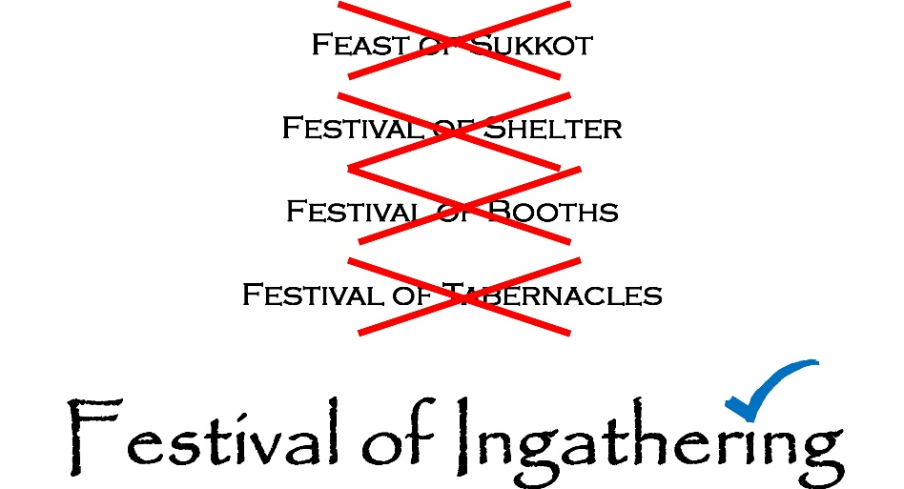

According to Exodus 23:14–17:
There are three appointed harvest festivals each year:
“Three times a year you shall observe a festival for Me:
(1) Keep the Festival of Unleavened Bread (Matzot). For seven days, as I commanded you, you are to eat unleavened bread at the appointed time in the month of Aviv (the spring season), for it was in that month you came out of Egypt. No one shall appear before Me empty-handed.
(2) Observe the Festival of Harvest, the firstfruits of your labors from what you sow in the field.
(3) And the Festival of Ingathering, at the end of the year, when you gather in your produce from the field.
Three times a year all your males shall appear before the Sovereign ONE, .”

Notice that the third appointed time is called the Festival of Ingathering, not specifically as “Festival of Tabernacles” or “Feast of Sukkot”. However, Leviticus 23:33–43 and Deuteronomy 16:13–15, did mention “to observe the festival of the booths for seven days”, but this is not what it highlights as, one of the three festival harvest of the year. In another word, want us to observe the festival by dwelling in a temporary booth for seven-day time of rejoicing, remembrance, and thanksgiving for the final harvest and for the Creator’s provision in the wilderness.
The Three Annual Pilgrimage Festivals
- Festival of Unleavened Bread – In the spring, commemorating the Exodus from Egypt.
- Festival of Harvest (Shavuot) – Early summer, celebrating the wheat harvest and the giving of the five books of the Laws, Decrees, and Judgments.
- Festival of Ingathering – In the fall, marking the completion of the year’s harvest and memorializing how the Israelites dwelled in temporary shelters in the wilderness.
These three appointed times required all men of Yisrael to appear before the Creator:
- Exodus 23:14–17 – The initial command.
- Exodus 34:23–24 – The reaffirmation of this command, with the promise that no one would covet their land while they were away obeying this pilgrimage.

The Temporary Booths Looks Like?
The booth was a type of temporary shelter—essentially a tent. During their 40 years in the wilderness, the Yisraelites lived in these tents, often made of goat hair, called sackcloth, similar to Bedouin tents still used today. These tents were dark in color and patched as needed.
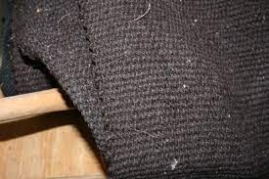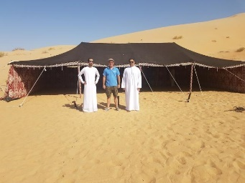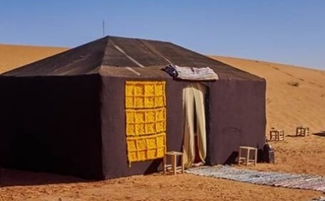
The Tabernacle (Mishkan), a larger and more sacred tent, was constructed from goat hair, tanned ram skins, sea cow hides, teḥashim skins, and acacia wood (see Exodus 26). This shows that the Israelites did not originally dwell in wooden “huts” covered with palm branches, but in fabric-based tents suitable for travel and desert conditions.
(https://www.biblegateway.com/passage/?search=Song+of+Solomon+1%3A5%3B+4%3A1%3B+2+Samuel+11%3A11%3B+Isaiah+50%3A3%3B+1+Kings+21%3A27%3B+2+Kings+19%3A1%2C+Dan.+9%3A3%2C+Jonah+3%3A5&version=TLV;LEB;OJB;DRA).
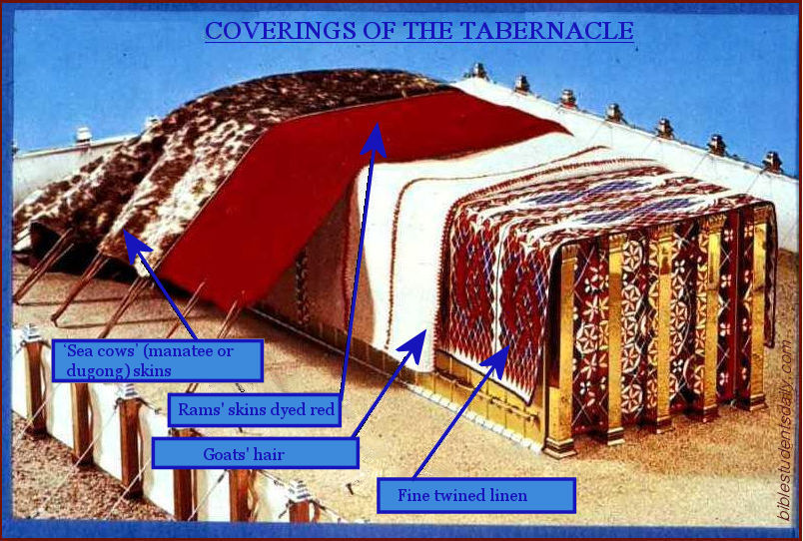

The Command to Travel and Dwell
Deuteronomy 16:16 explains:
- The Travel: All males were to appear before the Creator ONE, “in the place which He shall choose” (wherever the Tabernacle was set up).
- The Dwelling: All people were to live in temporary booths for seven days.
- The Security: Exodus 34:24 promises protection—no one would covet their land while they journeyed to appear before the Sovereign ONE, .
The Purpose of Leaving Home
The command to live in temporary shelters had two key purposes:
- To Remember – It served as a memorial of how the Israelites lived in temporary dwellings during their journey from Egypt.
- To Depend – Leaving the security of their permanent homes reminded the people to trust entirely in ’s protection and provision.
Thus, although the structure of the booth was simply the appointed time for the Festival of Ingathering, joyful community gathering that united the people in worship, thanksgiving, and remembrance of ’s creation as well.

